GROUP NAME: NEXTWAVE CODERS
PROJECT TITLE: DEVELOPMENT OF EMERGENCY DIGITAL HEALTH ID SYSTEM
MEMBERS
KEVIN ACHAE (IN16/00080/23)
KENYORU RAPHAEL (IN16/00039/23)
PETER ONGERO (IN16/00109/23)
KIMUTAI RONO (IN16/00110/23)
JOTHAM MASABA (IN16/00026/21)

DECLARATION
I hereby declare that this project work titled "Development of Emergency Digital Health
Identification System" is our original work and has not been submitted elsewhere for any
academic award. All sources of information used have been duly acknowledged.

DEDICATION
This project is dedicated to healthcare professionals and emergency responders who work
tirelessly to save lives, and to patients who deserve better access to their critical health
information during emergencies.

ACKNOWLEDGEMENT
We would like to express our most sincere gratitude to our supervisor Dr. Teresa Abuya for her valuable guidance, insightful feedback, and steadfast support throughout the course of this project. We are also greatly thankful to Almighty God for his divine wisdom, strength, and protection without which this work would not have been possible. We would wish also to thank all participants who provided valuable feedback during the system development and testing phases.

Table of contents
DECLARATION 2
DEDICATION 3
ACKNOWLEDGEMENT 4
List of tables 10
List of figures 10
ABSTRACT: 11
CHAPTER ONE 12
1.0 INTRODUCTION 12
1.1Background Information 12
1.2 Problem Statement 16
1.3Objectives 16
General Objective 17
Specific Objectives 17
1.4 Research Questions 17
1.5 Hypothesis 17
1.6 Significance of the Study 18
1.7 Justification 18
1.8 Scope and Boundary 20
CHAPTER TWO: LITERATURE REVIEW 23
2.1 Introduction 23
2.2 Related Work 24
2.2.1 Electronic Health Record Systems 24
2.2.2 National Health Identification Systems 25
2.2.3 QR code-based healthcare systems 25
2.2.4 Emergency Identification Cards and Medical Bracelets 26
2.2.5 National Digital Health ID Programs 26
2.2.6 Emergency Response Information Systems 26
2.2.7 Cloud-Based Personal Health Record Systems 27
2.2.8 Biometric Emergency Identification Systems 27
2.2.9 NFC-Based Medical ID Tags 27
2.2.10 Electronic Health Record Interoperability Projects 27
2.2.11 Smart Healthcare Wearables and IoT Devices 28
2.2.12 Portable Emergency Medical Devices With Data Storage 28
2.2.13 SMS-Based Emergency Medical Alerts 28
2.2.14 Wristband Identification Systems for Hospitals 29
2.2.15 Disaster Response Information Systems 29
2.2.16 Wearable GPS Emergency Trackers 29
2.2.17 Blockchain-Based Health Record Systems 29
2.3 Challenges of Existing Techniques 30
2.4 Summary of Gaps 31
CHAPTER THREE 34
3.0 METHODOLOGY 34
3.1 System Development Methodology 34
3.2 Analysis and Design Tools 36
3.2.1 Data Flow Diagrams (DFD) 36
1.Level 0 DFD. 36
Level 1 DFD. 36
3.2.2 Entity-Relationship Diagrams (ERD) 37
3.2.4 Unified Modeling Language (UML) Diagrams 40
3.2.5 Flowcharts 44
3.3 System Implementation Tools/Techniques 45
3.3.1 Frontend Implementation 45
3.3.2 Backend Implementation 46
3.3.3 Database Implementation 47
3.3.4 Security Implementation 47
3.3.5 Development Tools 48
3.4 System Testing and Validation 48
3.4.1 Unit Testing 48
3.4.2 Integration Testing 49
3.4.3 System Testing 49
3.4.4 Security Testing 49
3.4.5 Performance Testing 49
User Acceptance Testing 49
3.4.7 Validation Methods 49
CHAPTER FOUR 51
4.0 SYSTEM ANALYSIS & DESIGN 51
4.1 System Analysis 51
4.2 Requirement Specification 52
4.2.1 Functional Requirements 52
4.2.2 Non-Functional Requirements 60
4.2.3 Hardware & Software Requirements 61
4.3 System Design 62
4.3.1 System Architecture 62
4.3.2 Database Design 63
4.3.3 Interface Design User Interface Design: 69
Security Architecture 70
4.3.5 Physical and Logical Design Physical Design: 70
CHAPTER FIVE 72
5.0 SYSTEM IMPLEMENTATION, TESTING & VALIDATION 72
5.1 System Implementation 72
5.1.1 Backend Implementation 72
5.1.2 Frontend Implementation 73
5.1.3 Integration Implementation 74
5.1.4 Security Implementation 74
5.2 Testing Strategy 75
5.2.1 Unit Testing 75
5.2.2 Integration Testing 75
5.2.3 Functional Testing 75
5.2.4 Security Testing 75
5.2.5 Performance Testing 76
5.2.6 User Acceptance Testing 76
5.3 Validation System 76
5.3.1 Functional Validation 76
5.3.2 Non-Functional Validation 77
5.3.3 Compliance Validation 77
5.3.4 User Validation 77
CHAPTER SIX 79
6.0 SUMMARY, CONCLUSIONS AND RECOMMENDATIONS 79
6.1 Summary 79
6.2 Conclusions 80
6.3 Recommendations 82
REFERENCES: 84

List of tables
Table 1 Structure of the patients table 61
Table 2 Structure of the profile table 61
Table 3 Structure of the emergency contact table 62
Table 4 Structure of the medic table 63
Table 5 Structure of the medical record table 63
Table 6 Structure of the document table 64
Table 7 Structure of the analytic table 64
Table 8 Stucture of the audit log table 65

List of figures

Figure 1level 0 DFD diagram 34
Figure 2 level 1DFD diagram 35
Figure 3 ERD diagram for the Emergency Digital Health ID System 36
Figure 4 Use case diagaram 37
Figure 5 UML Class diagram 39
Figure 6 UML Sequence diagram 40
Figure 7 UML Sequence diagram 2 40
Figure 8 UML Activity diagram 41
Figure 9 UML component diagram 42
Figure 10 flowchart for the emergency digital health id system 44

ABSTRACT:
In this project, we focus on developing and testing a web-based Emergency Digital Health ID system that allows healthcare teams to access patient information quickly and securely in urgent situations. The system uses QR codes to improve patient identification, while a central medical database keeps records reliable and up-to-date. Role-based access ensures sensitive information stays protected. Each patient has a unique, encrypted QR code tied to an online profile containing key health details like blood type, allergies, and medical history. Healthcare staff retrieve this information by scanning the QR code and logging in via the web portal. To check the system’s performance, we measured response times and observed user interactions during simulated emergencies. The results show faster identification, more accurate data handling, and stronger protection against leaks than conventional approaches. Overall, this demonstrates that secure online ID systems can enhance the quality, safety, and reliability of emergency care.

CHAPTER ONE
1.0 INTRODUCTION
1.1Background Information
We know that providing effective healthcare depends on having quick access to reliable patient information (WHO, 2024). In emergencies, every second counts, and even small mistakes can be serious (UNICEF, 2023). We often rely on details like allergies, blood type, current medications, and pre-existing conditions to make decisions. But many patients arrive unable to communicate due to injuries, shock, or unconsciousness (Collins et al., 2023). Some may be confused or disoriented. When patients cannot share their medical or personal information, we have to make decisions with limited knowledge. This uncertainty can cause mistakes, wrong treatments, or delays in care (Pratley, 2016).
Identification in many healthcare environments is based on physical materials like identity cards and hospital files. These get lost, damaged, or are not available in times of emergencies (Ngere et al., 2024). Rarely will an accident victim carry medical records with him. Even if an identity card is available, it lacks the history of the patient's medical problems. Consequently, it becomes a matter of manually searching records or awaiting the arrival of relatives to identify the person. This is a time-consuming operation (KNBS & ICF, 2022). A few minutes in emergency medicine make all the difference between saving the patient or having complications. In this way, the limitation of physical records makes response during emergencies very difficult and unreliable. According to Cresswell & Sheikh (2013).
Emergencies are an unpredictable environment. Patients who are involved in accidents, natural disasters, or sudden medical events often come in unable to communicate (Dehghani et al., 2025). Head injuries, shock, or emotional trauma may affect memory. Some patients simply collapse in public places where no relatives are around. In such cases, identification becomes a big barrier. A patient without identity is a patient without history. Without history, treatment becomes insecure (WHO, 2024).
Most health facilities are still using paper-based records or semi-digital processes. This is of course different depending on location and funding. The well-funded hospitals utilize computers and servers, while smaller clinics depend on filing cabinets and folders. There are many weaknesses to using paper records: the files are damaged by water, fire, dust, and frequent use; they may be misplaced or removed on purpose; manually searching through physical folders is slow, and the information inside is often incomplete (Kenya Ministry of Health, 2021). Emergency situations need speed, not storage rooms.
Digital health records were introduced to modernize medical documentation. In their electronic format, they can be updated faster and data retrieved more easily under normal conditions (Ochieng et al., 2024). However, most digital systems have been developed for administrative and reporting purposes rather than responding in crises. Navigation is complex; authorization procedures are rigid. Many systems have been built around clerical needs rather than emergency workflows. The result is that essential details are buried within numerous screens. Emergency responders do not have time to search (Bigham et al. (2018).
The other limitation is that the medical systems are mostly confined to the internal network. One hospital cannot access the patient records of another unless they are formally transferred (Vatsa et al., 2025). Whenever patients are transferred, the information is not transported along with them. Every new hospital will create a duplicate identity for the same person. This duplication causes confusion, conflict of identity, and repetition of unnecessary medical tests. Sometimes, physicians order repeating tests simply because their previous results are not available. It is a waste of time and resources (UNICEF, 2023).
Infrastructure also plays a part. Many systems work only when there is electricity and stable network connections. Power failures disrupt hospital operations; network outages prevent access to cloud-based platforms. Systems also collapse in the face of disasters such as floods or fires—exactly when they are needed most (Ngere et al., 2024). Reliability needs to take into account reality. Systems constructed for ideal environments often fail when the pressure begins.
Mobile computing has transformed health operations. Smartphones are now a staple for medical professionals (Collins et al., 2023). Applications enable monitoring, appointment management, and reporting. Yet despite this growth, the digital identification tools haven't kept pace. Most health apps are about monitoring, not about patient identity. Identification is an afterthought. Yet, everything else depends upon identification.
QR technology provides an inexpensive identification medium. QR codes can be printed on cards, wristbands, or tags. They require no special equipment other than a basic camera. Because of this ease of use, they are practical in healthcare environments. However, QR codes must be used correctly. If they store personal data openly, they create privacy risks. If they redirect to insecure links, they invite exploitation. QR codes are not secure by default; they're only as reliable as the systems behind them. According to Karia et al. (2018).
Too many of the existing QR-based projects treat the code as storage, instead of as access. They store blood type, allergies, or even ID numbers directly in the code. Anyone who could scan it gains access. This is a violation of privacy (Pratley, 2016). Other systems link QR codes to online profiles without user verification to allow others to view them. Neither approach meets healthcare standards. Security must be designed into the architecture (Vatsa et al., 2025).
The following project presents an online centralized access solution. The QR code itself will not store data; instead, it provides access to a secured database. After scanning the code, the system will authenticate the user and retrieve the information from the server. Since the information will never be exposed inside the code, it stays secure. The server controls the access to data. Permissions are also checked before display thus keeping the system flexible and safe (Kenya Ministry of Health, 2021).
Architecture available only online provides reliability of content. Data being stored centrally ensures consistency. When a patient updates information, the change reflects immediately. There is no version conflict. There is no outdated data printed on a card. Doctors get the latest record at scan time. Centralization also allows monitoring. Administrators track system use and detect suspicious behavior. Activity logging becomes a security layer (Ochieng et al., 2024).
Security is the key. Medical information invites abuse. ID fraud, identity theft, and even extortion flourish in an environment where patient information is poorly secured (UNICEF, 2023). Encryption and role-based control safeguard data in the system. A nurse sees what a nurse needs to know. A doctor sees much more. An administrator manages access. Each role carries with it defined privileges (Vatsa et al., 2025).
This project also illustrates the relevance of software engineering beyond classrooms. It combines design models, database management, system testing, and cybersecurity measures. The software is not a simulation; it is a real-life solution. This increases its academic and practical value (Collins et al., 2023).
Emergency health care is unlike other health care: it must be rapid, unplanned, and hazardous. Only minimalist, reliable, and accurate software should be used in emergencies. Complex designs inevitably fail when stressed. Simplicity and resilience are emphasized in this project. A system that works only in perfect conditions is useless. Real software performs during failure. (Pratley et al., 2016).
Identification leads to treatment. Treatment leads to outcome. The chain shall not break. Where there is lack of identity, treatment slows down. Where treatment slows down, outcomes worsen. That is the problem this system addresses.
This project doesn't seek to replace healthcare systems; it connects them. It is a gateway to information, not a storage of everything, just what matters (WHO, 2024).
1.2 Problem Statement
Emergency care requires timely and accurate identification of the patient. The health professional needs to know about allergies, blood group, current medication, and emergency contact numbers, among others, as quickly as possible. Unfortunately, most patients are often admitted unconscious, incoherent, or even without identification. In such cases, healthcare providers have to perform under limited and no information conditions, often delaying timely treatment, making the wrong medical decisions, and creating serious health risks.
The majority of health facilities still rely on paper records, manual identification, or hospital-specific computer systems. Most of these systems do not communicate well with each other and often fail whenever a patient is under treatment outside their usual hospital. Additionally, internet access is unreliable in most areas; hence, the usage of online health systems becomes futile in emergencies. Because of this, health workers cannot always retrieve patient information when they need it most (Ozair, F.F., et al. (2015). Ethical issues in electronic health records.
While modern EHRs are implemented everywhere, they were never designed for emergency access. There are several QR-code solutions, but many are either static, insecure, or not linked to accurate medical records. This limits their utility during real emergencies that require speed, accuracy, and trust. Patients also have little control over who can view their medical data. This shows the need for a secure Emergency Digital Health Identification System that uses encrypted QR codes, access control, and interoperability to support safer and faster emergency care.

1.3 Objectives
General Objective
To design, implement and evaluate a secure Emergency Digital Health Identification System that allows authorized responders to retrieve critical information on a patient through QR-code scanning.
Specific Objectives
- Design a system generating unique digital health IDs to organize emergency patient data.
- Implement role-based access controls and authentication workflows to ensure secure and accountable system use.
- To evaluate how easy and accessible the system interface is for emergency responders.

1.4 Research Questions
- How would one design a unique patient identification framework that could precisely structure and store emergency medical information using standardized health data models?
- How well does the role-based access control prevent unauthorized data access while also maintaining accountability through audit logging?
- How well can the system interface be used by emergency responders to carry out important tasks of scanning, under conditions of simulated emergencies?

1.5 Hypothesis
This project is based on the hypothesis that an online emergency health identification system using encrypted QR codes and a central database will improve the speed and accuracy of patient identification, increase access to critical medical information, reduce treatment errors and delays, enhance privacy through role-based access control, and support safer emergency care outcomes compared to paper-based and fragmented systems.

1.6 Significance of the Study
This study holds immense value for a wide range of stakeholders within the healthcare ecosystem (World Health Organization, 2023). It affords emergency medical responders a speedy and sure means of determining essential patient information on which to base appropriate and timely treatment, thereby increasing survivability and reducing complication severity (Bigham et al., 2018). For the hospitals, the system eliminates delays related to searching for patient files or repetition of diagnostic tests due to missing information; it reduces operational costs from duplicated procedures and maintains workflow efficiency in emergency departments (Cresswell & Sheikh, 2013).
For the patients, the Emergency Digital Health ID System offers safety, convenience, and improved clinical outcomes (HIMSS, 2022). Patients suffering from chronic illnesses like diabetes, epilepsy, asthma, and hypertension are at a distinct advantage as their medical data would be instantly available during times of emergencies (Vest et al., 2019). Families also benefit through faster identification of loved ones involved in accidents (Karia et al., 2018).
At the national level, this project supports Kenya’s digital health transformation goals by providing a scalable solution that can be integrated with broader health information systems (Ministry of Health Kenya, 2020). It also contributes to research and innovation in emergency response technologies, setting a foundation for future developments in AI-driven emergency care tools (Topol, 2019). The system can also support disaster preparedness efforts through the timely identification and triaging of victims in mass-casualty incidents (World Health Organization, 2022). This research is thus important because it provides a practical, low-cost, and scalable approach to improving emergency healthcare outcomes in Kenya and beyond (World Bank, 2021).

1.7 Justification
Timely access to accurate patient information in emergency healthcare situations is very important (World Health Organization, 2023). In most healthcare settings and especially in developing areas, patient identification relies on paper records, physical identity cards, and unconnected electronic record systems, hence remaining a major challenge (Cresswell & Sheikh, 2013). In cases where patients arrive unconscious or without identification at the healthcare facility, providers rarely access vital medical information regarding their past illnesses, allergies, blood group, or ongoing treatment (Bigham et al., 2018). Such gaps have a tendency to delay medical decisions, increase incorrect treatment, and lower the quality of emergency care (Vest et al., 2019). We are carrying this project to address such limitations by designing an effective, secure, and reliable digital system that enhances patient identification and medical data access during emergencies.
With the rising usage of technology in health, there is a need for systems that are not only digital but also accessible and secure (HIMSS, 2022). While many hospitals have adopted electronic health records, most systems remain disconnected and limited to individual health facilities (Adler-Milstein & Jha, 2017). A patient treated in one hospital cannot transfer their medical history to another hospital easily, especially in cases of emergency (World Bank, 2021). This fragmentation ultimately compels the health caregivers to make decisions with incomplete information (Cresswell & Sheikh, 2013). The proposed Emergency Digital Health Identification System seeks to overcome these challenges by offering a centralized online platform that allows the authorized health personnel to retrieve a patient's medical information from a secure database through a QR code (Karia et al., 2018). This ensures continuity of care regardless of location and reduces reliance on physical documents (World Health Organization, 2022).
It also addresses the rising concerns about patient privacy and data security (Rumbold & Pierscionek, 2017). Medical information is sensitive and needs stringent protection (World Health Organization, 2020). Most of the QR code systems available either display information directly on the code or route users to unsecured web pages (Karia et al., 2018). Such approaches expose patient data to misuse (Fernández-Alemán et al., 2013). The proposed system enforces authentication, access control, and encrypted communication for making sure that only authorized users can view patient records (ISO/IEC, 2022). Such security ensures more trust by the patients and addresses their concern to comply with ethical standards related to data protection (Rumbold & Pierscionek, 2017).
Several groups will benefit from the project. The patients benefit by improved safety, faster treatment, and reduction of medical errors (Vest et al., 2019). The healthcare professionals’ benefit by immediate access to important data about the patient, which improves decision-making under pressure (Bigham et al., 2018). The hospital administrators benefit by reducing manual handling and improving the organization of records (HIMSS, 2022). The broader health system benefits from adopting more efficient methods of managing patient information that support digital transformation (World Bank, 2021).
This new system replaces isolated, undependable methods of identification with a single digital platform; as opposed to the traditional systems that were dependent on memory, paperwork, or facility-bound databases, this proposed solution uses online access and QR code technology so that patient information is always current and accessible (World Health Organization, 2023). This can reduce delays in treatment, help in accurate diagnosis, and enhance health care delivery (Topol, 2019).

1.8 Scope and Boundary
The project involves the design, implementation, and evaluation of a web-based Emergency Digital Health ID System that allows authorized healthcare personnel to access patient medical information using encrypted QR codes (World Health Organization, 2022). The system includes a centralized database for patient records, a web interface for healthcare staff, and QR code generation and scanning modules (Karia et al., 2018). It implements user authentication and role-based access control to ensure secure and accurate data access (Fernández-Alemán et al., 2013). Patients can register and manage their emergency medical profiles, while emergency responders and clinicians retrieve critical information according to assigned roles (Bigham et al., 2018). The study evaluates system performance, data accuracy, accessibility, usability, and security through simulated emergency scenarios, using measures such as identification time, task completion time, response time, and data integrity (Vest et al., 2019). It also conceptually supports integration with hospital systems using standardized data exchange formats (HL7 International, 2021).
The project is limited to an online-only model that requires an active Internet connection and does not support offline access, data caching, or synchronization (World Bank, 2021). It provides a responsive web-based interface and does not develop native mobile applications (HIMSS, 2022). Hardware-related issues, including device availability, scanner performance variations, and network instability, are not examined in depth (Cresswell & Sheikh, 2013). The study excludes clinical decision-making, diagnosis algorithms, automated treatment recommendations, biometric technologies, and wearable device integration (Topol, 2019). The system does not replace hospital information systems; it complements them by facilitating emergency identification and access to existing patient information without interpreting medical data (World Health Organization, 2023).

CHAPTER TWO: LITERATURE REVIEW
2.1 Introduction
Emergency healthcare delivery is deeply dependent on correct identification of the patient and timely access to medical information (World Health Organization, 2023). The healthcare providers need to make quick decisions in critical conditions without having the complete history of the patient (Bigham et al., 2018). Over time, various digital health technologies have been designed and developed to facilitate information management within hospitals, such as electronic health records, biometric identification systems, and QR-code-based solutions (Adler-Milstein & Jha, 2017). These were introduced mainly to reduce paperwork, clinical errors, and support data sharing within hospitals (Cresswell & Sheikh, 2013).
Despite the significant investment in digital technologies, the literature also demonstrates that many healthcare systems fail in emergencies (Vest et al., 2019). Most digital solutions have been designed for routine clinical purposes and are not fit for urgent care environments (Bigham et al., 2018). Such studies also note various problems like inaccessible patient records, incompatible databases, and weak security controls (Fernández-Alemán et al., 2013). Therefore, emergency responders often have incomplete or outdated information; this results in delayed treatment and raises medical risk (World Health Organization, 2022).
This section reviews the different existing identification and health information systems, focusing on the way they work, where they are used, and their main weaknesses (Cresswell & Sheikh, 2013). The focus is to understand the approaches taken so far and to identify research gaps that may justify the development of an innovative online emergency identification system based on QR code and centralized data access (Karia et al., 2018).

2.2 Related Work
2.2.1 Electronic Health Record Systems
In developed countries, EHR systems are being used for storing and maintaining patient information (Adler-Milstein & Jha, 2017). EHR platforms are utilized by hospitals to record clinical data of patients, such as medication history, laboratory reports, and diagnosis notes (World Health Organization, 2022). EHR systems were first targeted at achieving enhanced organizational efficiency, coupled with a reduction in paper records (Cresswell & Sheikh, 2013).
However, most of the studies prove that EHRs are optimized for administrative workflows rather than emergencies (Bigham et al., 2018). Usually, record searches require name entry, hospital number, or manual verification—all of which is impossible to execute when the patient is unconscious (Vest et al., 2019). Research also points out that most hospitals use different EHR vendors and database designs, making system-to-system communication difficult (Adler-Milstein & Jha, 2017).

2.2.2 National Health Identification Systems
Some countries have implemented national digital health identification systems. The very valid example is the Aadhaar-based health identity of India. In this program, every citizen has a number that links to health records (Kshetri, 2017). UK uses an NHS number, and Estonia is operating a fully digital health system in which medical records follow patients across facilities.
These systems enhance long-term data continuity; however, they have various limitations. For one, complete integration has not occurred across all healthcare facilities. Full operation during emergencies is often not possible due to infrastructural challenges. Dependence on the availability of networks also leaves these systems vulnerable to downtime.

2.2.3 QR code-based healthcare systems
QR code solutions have been introduced to simplify the process of patient tracking, appointment scheduling, and access to basic medical information (Karia et al., 2018). The QR wristbands are pilot tools employed in various hospitals both in Asia and Africa to hasten check-in procedures (World Health Organization, 2022). QR systems reduce paperwork and accelerate identification (Cresswell & Sheikh, 2013). In spite of all these advantages, the literature also strongly criticizes QR systems for their poor security design: very few solutions securely store personal data online but embed it in the QR code (Fernández-Alemán et al., 2013). Anyone who has a scanner can access sensitive data if no access control is applied (Rumbold & Pierscionek, 2017). On top of that, many QR systems are installed as stand-alone applications without integration into wider healthcare platforms (Vest et al., 2019).
2.2.4 Emergency Identification Cards and Medical Bracelets
Until digital solutions became common, many patients relied on physical emergency identification items like medical ID bracelets, wallet cards, and ICE tags (Topol, 2019). These tools usually can provide only very basic information about a person's blood type, known allergies, and an emergency contact (World Health Organization, 2023). While simple and easy to carry, they offer little room for detailed medical history or recent diagnoses or lists of medications (Bigham et al., 2018). Another problem is that they cannot be updated without physically replacing the card or bracelet (Vest et al., 2019).
Another issue is that physical IDs can get lost, damaged, or ignored because responders expect more detailed information (Cresswell & Sheikh, 2013). In contrast to such traditional tools, your system provides one centralized emergency profile that can be updated anytime and retrieved instantly, thereby offering more utility while still being simple to access (Karia et al., 2018).

2.2.5 National Digital Health ID Programs
Some countries have developed national digital health record platforms aimed at linking hospitals, clinics, and laboratories (World Bank, 2021). Examples include the systems currently in place in Estonia, India, and Kenya (World Health Organization, 2022). These solutions are national in scope; they are focused on long-term medical recordkeeping, hospital transfers, and clinical decision-making (Adler-Milstein & Jha, 2017). They also function quite well within health facilities, though they rely a great deal on national infrastructure, hospital networks, and professional authentication (HIMSS, 2022). This is where there is a challenge in emergencies: the national systems are not immediately accessible by paramedics in the field (Bigham et al., 2018).
Your system fills this gap by providing an emergency-specific layer that delivers key medical information without relying on hospital systems or complex national authentication processes (Vest et al., 2019).

2.2.6 Emergency Response Information Systems
Most of the countries have digital platforms to capture the patient's information during the ambulance dispatch (World Health Organization, 2023). They are mostly integrated with the EHR at hospitals, which requires the staff to log in (Bigham et al., 2018). These systems enable the tracking of patient vitals, treatments given within an ambulance, and information regarding handovers (Vest et al., 2019). However, they do not locate an unconscious patient or one without identification (Cresswell & Sheikh, 2013). The paramedics should still guess or assume in case the patient does not voluntarily give this information or has pre-registration with the hospital (World Health Organization, 2022).
Your system acts like a pre-hospital identification tool, assisting emergency responders before the patient reaches a health facility, filling a gap that EMS software cannot cover (Karia et al., 2018).

2.2.7 Cloud-Based Personal Health Record Systems
Cloud-based PHR systems give patients control over their health information by enabling them to upload and manage their medical details online (Rumbold & Pierscionek, 2017). These tools are accessible from any part of the world but are dependent on reliable internet connectivity (World Bank, 2021). In some instances, multi-step authentication processes are required, rendering them inappropriate for use during emergencies (Fernández-Alemán et al., 2013).
The user interfaces can be complicated for elderly people or for those with low digital literacy (Topol, 2019). Your project simplifies the idea of health record access to only the most necessary information in an emergency and presents it in a fast and accessible manner (Vest et al., 2019).

2.2.8 Biometric Emergency Identification Systems
Biometrics such as fingerprints or face identification are also used in some hospitals to access patient records (HIMSS, 2022). These solutions are very secure and accurate but require specialized scanners and are costly to deploy outside the environs of a hospital (World Health Organization, 2022). In emergencies, a patient's physical condition may also render biometrics unreliable—for example, injuries, burns, or swelling may prevent a fingerprint scan (Bigham et al., 2018). By contrast, the QR-based solution works on any mobile phone, does not require expensive infrastructure, and does not need specialized devices (Karia et al., 2018).
2.2.9 NFC-Based Medical ID Tags
These have been used in devices like embedded medical tags, storing emergency information that can be accessed when tapped with a phone (Topol, 2019). Although NFC is convenient, not all phones support NFC scanning, with some models even placing restrictions on NFC operations (HIMSS, 2022). NFC tags also operate within a very short communication range and may malfunction with water contact or damage (World Health Organization, 2023). Your system uses QR codes, supported by practically all smart phones, which are more reliable in real emergency situations (Karia et al., 2018).

2.2.10 Electronic Health Record Interoperability Projects
EHR interoperability seeks to standardize patient information across hospitals and between medical facilities (HL7 International, 2021). Standards such as HL7 FHIR or solutions such as Open MRS allow safe information exchange between different institutions (World Health Organization, 2022). Such systems are critical in the instances of long-term care and referrals; however, they are not optimized for emergency field response (Bigham et al., 2018). A paramedic will not have easy, timely access to these systems without a hospital login or connection (Vest et al., 2019). Your system complements EHR interoperability by offering a lightweight, emergency-oriented access layer, tailored for rapid medical identifications (Karia et al., 2018).
2.2.11 Smart Healthcare Wearables and IoT Devices
Wearable technology includes smartwatches that can collect vitals in real time, such as heart rates, blood oxygen levels, and sleep patterns (Topol, 2019). These tools are useful but do not contain complex medical history, nor can they, independently, function as identification in emergencies (World Health Organization, 2023). They require batteries that could also fail at any moment (HIMSS, 2022). Your system offers a more stable and medical-specific solution in that the system stores essential emergency information independently from any wearable device performance (Vest et al., 2019).

2.2.12 Portable Emergency Medical Devices With Data Storage
Some emergency devices, such as advanced insulin pumps, pacemakers, and digital inhalers, store limited data within the device's memory (World Health Organization, 2022). In some cases, this information can be downloaded using specialized hospital equipment (Topol, 2019). While useful, these devices are not designed to convey critical medical information to responding first responders in the field (Bigham et al., 2018). They require personnel training, proprietary software, and, in many instances, patient cooperation (Cresswell & Sheikh, 2013). Their data is also device-specific and does not represent the patient's broader medical history (Vest et al., 2019). Your system provides a more universal method that does not depend on specialized hardware and can be accessed by any emergency worker with a smartphone (Karia et al., 2018).

2.2.13 SMS-Based Emergency Medical Alerts
Patients with chronic conditions in some countries enroll in SMS alert services that send notifications to their healthcare providers or family members in case of emergencies (World Bank, 2021). These platforms, however, are dependent on whether the mobile network is available, the conscious state of the patient, and the ability of the patient to operate a phone (World Health Organization, 2023). These platforms also do not convey detailed medical information directly to paramedics (Vest et al., 2019). They help inform contacts but do not solve giving the first responders the information they need as soon as possible (Bigham et al., 2018). In this regard, your system ensures that responders will be able to know the updated medical records without depending on the patient’s device or sending messages (Karia et al., 2018).
2.2.14 Wristband Identification Systems for Hospitals
Many hospitals today use barcoded wristbands to identify patients upon admission (HIMSS, 2022). This wristband is scanned by hospital personnel for identification purposes, fetching of hospital records, medicine administration, and tracking of admissions (World Health Organization, 2022). However, wristbands function within the confines of a hospital system and require hospital equipment for reading (Cresswell & Sheikh, 2013). It is useless outside the confinement of a hospital environment and is not capable of storing medical information on its own (Vest et al., 2019). Your system extends the idea of rapid identification out into the real world, making identification and medical access possible even before reaching a hospital (Karia et al., 2018).

2.2.15 Disaster Response Information Systems
Large-scale emergencies, such as natural disasters or mass-casualty incidents, utilize specialized information systems to track victims, reunite families, and support medical triage (World Health Organization, 2023). These systems are designed for large operations and require coordinated teams, network infrastructure, and dedicated equipment (World Bank, 2021). They do not address the everyday individual emergencies, like accidents, asthma attacks, allergic reactions, or diabetic crises (Bigham et al., 2018). This leads to the need for a simpler emergency identification solution on an individual basis (Vest et al., 2019). Your system fulfills this requirement by offering a personalized tool for emergency information useful both in routine and large-scale emergency situations (Karia et al., 2018).

2.2.16 Wearable GPS Emergency Trackers
Wearable GPS trackers are worn by elderly patients, children, and people with chronic diseases to enable caregivers to track location during emergencies (Topol, 2019). While they track the location of the patient, they lack any details on medical history, allergies, or medications (World Health Organization, 2022). They are more oriented to safety and tracking than to medical decision support (HIMSS, 2022). Your system adds value in that it links identification with detailed medical information available via a QR code (Karia et al., 2018).
2.2.17 Blockchain-Based Health Record Systems
Some research projects have aimed at the usage of blockchain in storing patient records in tamper-proof formats (Rumbold & Pierscionek, 2017). These systems enhance data integrity and privacy but are computationally heavy, expensive to deploy, and require specialized infrastructure (World Bank, 2021). They are also not built for immediate field access since most blockchain platforms are complex and require authentication steps (Topol, 2019). Your system is lighter and more practical, hence suitable for real-time emergency response (Vest et al., 2019).

2.3 Challenges of Existing Techniques
Author | Year | Method used | Strengths | Weaknesses
Abdul-Jabbar Farhan | 2023 | Secure QR-code generation | Strong encryption | Limited real- world deployment
Zhang et al. | 2021 | mHealth QR system | Good accessibility | Dependent on mobile internet
Mahat | 2024 | AI+QR generation | Fast diagnosis | High computational demand
World health organization (WHO) | 2022 | Digital heath id framework for LMIC emergency systems | Standardized guidelines: improves coordination | Limited local adaptation: costly to maintain standards
Johnson et al. | 2024 | AI-supported emergency data system | Faster diagnosis; reduces human errors | Requires high quality datasets; training costs
Pillay&Nkosi | 2023 | SMS-based emergency medical information access | Works on basic phones, easy to deploy | Low data capacity; limited security
Saeed&Abdalla | 2023 | Cloud-based medica report retrieval with encrypted tokens | Secure cloud storage; real time access | Requires stable internet; high server costs
Hussain et al. | 2023 | Blockchain-enabled medical history sharing | High integrity and traceability; tamper-proof | Expensive infrastructure; slower transaction speeds
Faggiano et al. | 2021 | Systematic review | Wide evidence scope | Few practical systems

2.4 Summary of Gaps
Many QR systems store personal information within the code itself or link to unsecured web interfaces without authentication. Kuo et al. (2011) highlighted privacy risks and failures of access control as major weaknesses in QR-driven healthcare systems. Most implementations operate as isolated tools rather than part of an integrated health platform.While there are several interoperability standards, security frameworks, and modernization strategies proposed by researchers (WHO 2019; Kruse et al. 2018), very few operational systems exist that put together all these suggestions into one workable solution with a focus on emergency identification. Most of the available systems resolve only one aspect of the problem-record storage, identification, or security-but do not combine them into one workable platform.
The identified research gap is the absence of a secure, centralized, online emergency identification system that connects patient identity to real-time medical records through controlled access. Existing EHR systems fail during emergency conditions, national health platforms lack integration, and QR-based solutions expose patient data due to weak security design. This project directly responds to the limitations that Evans described in 2016, regarding the poor emergency usability of EHRs, and Kuo et al. described in 2011 concerning the security weaknesses of QR-based healthcare tools. This introduces a system that integrates authentication, encryption, centralized data management, and real-time emergency access into a single application for crisis scenarios.

CHAPTER THREE
3.0 METHODOLOGY
3.1 System Development Methodology
The proposed system, called the Emergency Digital Health Identification System, was developed following an iterative and incremental approach for software development, with the adoption of some principles of Agile software development methodology and RUP.
We chose this approach because it enables refinements to be made continuously, provides for early feedback from users, and also allows for changes in requirements, a very important feature in healthcare systems where user needs and regulatory requirements may change over time.
The development process was organized into several iterations, each focusing on specific functional aspects of the system.
The first iteration focused on core functionality like user authentication, patient registration, and basic profile management. Further iterations then integrated QR-code generation and scanning capabilities, dashboard interfaces, medical record management, and analytics.
Each iteration included requirements analysis, design, implementation, testing, and user feedback collection phases. Iteration allowed the identification and resolution of technical challenges, user experience issues, and security concerns at a very early stage.
Regular reviews and tests throughout the development process ascertained that the system met the quality standards and functional requirements while moving on to the next iteration.
This methodology also enabled incremental deployment and testing, thus allowing validation of individual components before system integration.
the development team was organized in a collaborative style, which included periodic communication, code reviews, and documentation updates. version control using git enabled effective collaboration and change management throughout the development process.
the methodology emphasized documentation at each stage, ensuring that design decisions, implementation details, and testing results were properly recorded for future reference and maintenance.

3.2 Analysis and Design Tools
the system analysis and design phase utilized several modeling and design tools to ensure comprehensive system understanding and effective design documentation.
these tools facilitated communication among stakeholders, provided clear system specifications, and guided the implementation process.
3.2.1 Data Flow Diagrams (DFD)
Data Flow Diagrams were used to model the flow of information through the system at different levels of abstraction.
Level 0 DFD.
The context diagram (Level 0 DFD) identified the system boundaries and external entities including patients, healthcare providers, authentication services, and database systems.
Patient
Admin
Emergency staff
Generate/Update QR code
Scan QR code

View Emergency profile

Manage users

Emergency Digital Health ID System

Figure 1 level 0 DFD diagram

Level 1 DFD.
Level 1 DFDs detailed the major processes including user authentication, patient registration, QR code generation, health information retrieval, and medical record management.

PATIENT
Emergency staff module
ADMIN
2.patient profiles
D2 codes
Admin control interface
D1 Q codes
QR scanning profiles
QR scanning interface
D5. System administration
1.2 profile management

1.User authentication

Admin module
Patient module

Figure 2 level 1DFD diagram

The DFDs helped identify system boundaries, data requirements, process dependencies, and potential bottlenecks. They also facilitated identification of security checkpoints and data validation requirements throughout the system.
3.2.2 Entity-Relationship Diagrams (ERD)
Entity-Relationship Diagrams were used to model the database structure and relationships between different data entities.
The ERD identified key entities including Patient, Profile, Medic, Medical Record, Emergency Contact, Document, Analytic, and Audit Log. Relationships between entities were defined, including one-to-many relationships between Patient and Medical Record, Patient and Emergency Contact, and Medic and Medical Record.
The ERD helped ensure data integrity, identify required indexes for performance optimization, and guide database schema design. It also facilitated understanding of data dependencies and informed decisions about data normalization and denormalization for performance optimization.
Patient
Patient_ID (PK) Name Date_Of_Birth
Emergency Contact
Contact_ID (PK) Patient_ID (FK) Name PhoneNumber
Document
Document_ID (PK) RecordID
Profile
Profile_ID(PK) Patient_ID (FK) Name Specialization
MedicalRecord
Record_ID(PK) Patient_ID(FK) Medic_ID(FK)
Medical Record
Record_ID (PK) Patient_ID (FK) Medic_ID(FK)
Analytic
Analytic_ID (FK) Patient_ID (FK) RecordID
Document
DocumentID (PK) RecordID File
AuditLog
Audit_ID (PK) Record_ID (FK) Action Timestamp

Figure 3 ERD diagram for the Emergency Digital Health ID System

3.2.3 Use Case Diagrams
We used use-case diagrams to model system functionality from a user perspective, identifying actors (Patient, Medic, Administrator) and their interactions with the system. Key use cases included patient registration, health ID card generation, QR code scanning, medical record creation, emergency contact management, and analytics viewing.
The use case diagrams helped us identify functional requirements, user roles, and system boundaries. They also facilitated user acceptance testing by providing clear scenarios for testing system functionality from the user's perspective.
Figure 4 Use case diagaram

patient
Extend
Extend
Scan QR code
Manage users
Log in
Generate QR code
Create emergency profile
View emergency profile
Register account
Include
Admin
Emergency

3.2.4 Unified Modeling Language (UML) Diagrams
Various UML diagrams were used to model different aspects of the system, which are:
- Class Diagrams: The object-oriented structure of the system was designed, representing the classes, attributes, methods, and relationships among classes. This helped guide the implementation of models, controllers, and services in the application.
Emergency digital health ID system

Admin
+manage access rights
Patient
+personal information
+medical conditions
+contact information

Emergency Staff

+authorization status
+access permissions
Emergency profile
+emergency information
+medical conditions

QR Code
+data

User
+username
+password

Figure 9 UML Class diagram

Figure 10 UML Class diagram

- Sequence Diagrams: Modeled the interaction between the system components over time, showing the flow of messages between user interfaces, controllers, services, and database layers. These diagrams helped identify communication patterns, error handling requirements, and opportunities for optimizing performance.
Emergency Profile
QR Code
System
QR Code
Emergency Profile
System
Create
Create Emergency Profile
Patient

Generate
Generate QR Code
Return QR Code

Figure 6 UML Sequence diagram

Emergency Staff
Emergency Digital Health ID Says
Hospital
Health Community
QR Code Scan
Authentication Status
Provide Profile Data
Provide QR Code
Patient

Figure 7 UML Sequence diagram 2

- Activity Diagrams: Modeled business processes and workflows, including, among others, patient onboarding, QR code scanning, and the creation of medical records. Such diagrams were able to reveal process steps, decision points, and requirements of exception handling.
System
Emergency Staff
Patient

Open system

Open account

Login
Profile exists?

Create Emergency Profile
Create QR Code

View Emergency Profile

New registration

Manage User accounts

Figure 8 UML Activity diagram

- Component Diagrams: Modeled the system architecture, showing major components including the frontend application, backend API, authentication service, database, and file storage. These helped to understand system dependencies and guide deployment planning.

<<component>>
Emergency

<<security>>
Infrastructure
Emergency Health ID System UI
<<UI>>
<<component>>
Update Personal

Persistence
Infrastructure
<<component>>
QR Code scan

Central Database
<<component>>
ScanQR RetrieveEmergency LogAccess
Patient Management
RegisterAccount() Login() UpdatePersonalDetails()

<<component>>
Emergency AccessService

Figure 9 UML component diagram

3.2.5 Flowcharts.
We used flowcharts to model complex algorithms and business logic, including QR code generation, data encryption, authentication flows, and error handling procedures. Flowcharts provided clear visual representation of decision logic and process flows, facilitating implementation and testing.
Token valid?
Validate validation
Create Parent orc
Present Record
Open Scanner/ Camera
Render record
Validate scan/verify
Validate Scan/ Verify
Create patient profile
Medical records
Add/Update notes
Generate Encrypted QR
Complete Emergency Profile
Start
Request health ID/QR
Complete emergency profile(name; DOB; Blood type; allergies)
Register/ Sign Up
Stop
Download/Print Health ID (PDF)
Open scanner/ Camera
Medical Records (collection)
Add/ Update notes
Auth Service/ Supprt
Database storage
Figure 10 flowchart for the emergency digital health id system

3.3 System Implementation Tools/Techniques
The system implementation utilized modern web development technologies and tools selected for their suitability to the project requirements, community support, and alignment with industry best practices.
3.3.1 Frontend Implementation
The front end was designed in React 19, a modern JavaScript library for user interface development. We chose React because of its component-based architecture for code reusability and maintainability.
The application utilizes React Router 7 for client-side routing, thus providing the possibility for an SPA and enabling navigation between different views smoothly.
State management was implemented with the use of Redux Toolkit, which provides a predictable state container for managing application state.
Redux was chosen for managing complex state requirements, such as user authentication state, patient data, and application configuration. The build process uses Vite, a modern build tool that provides fast development server startup and optimized production builds.
Vite was chosen for the performance benefits that it has over other build tools and because it supports React development.
The styling was done with CSS Modules, which offer scoped styling with the aim of preventing conflicts in styles and further improving maintainability. Iconography within the application was done using Material UI icons for consistency.
It also uses the jsqr library for QR-code scanning, which is responsible for decoding QR codes in JavaScript coming from camera streams. Therefore, it is able to provide an in-browser QR-code scanning without using native mobile applications.

PDF generation for health ID cards is handled client-side using html2canvas and jsPDF libraries, though the system also supports server-side PDF generation for improved quality and consistency.
3.3.2 Backend Implementation
We developed back-end using Node.js with Express 5 framework.
We selected Node.js for its JavaScript-based runtime, enabling code sharing between frontend and backend, and its excellent support for asynchronous operations and real-time applications. Express 5 provides a minimal and flexible web application framework for building RESTful APIs.
We also selected the express framework for its simplicity, extensive middleware ecosystem, and strong community support.
We handled database operations using Mongoose, an Object Data Modeling (ODM) library for MongoDB. Mongoose provides schema definition, validation, and query building capabilities, facilitating database operations and ensuring data consistency.
We implemented authentication using Supa base, a backend-as-a-service platform that provides authentication, user management, and JWT token generation. We selected supa base for its security features, ease of integration, and support for multiple authentication methods including email/password and OAuth providers.
In uploading files, we used Multer middleware, which processes multipart/form-data for file uploads. Multer was configured to handle patient profile photo uploads with size limits and file type validation.
QR code generation is implemented using the QR code library, which generates QR code images from data strings. The library supports various output formats and error correction levels, enabling generation of high-quality QR codes suitable for printing and scanning.
PDF generation for health ID cards is implemented server-side using PDFKit, which provides programmatic PDF generation with precise control over layout and formatting. This enables generation of standardized, professional-quality health ID cards.
We handled image processing using Sharp, a high-performance image processing library that provides resizing, cropping, and format conversion capabilities. Sharp is used to process patient profile photos and QR code images for optimal display and storage.
3.3.3 Database Implementation
The system adopts MongoDB, a NoSQL document database, for data persistence. MongoDB was chosen for its flexibility in schema design, scalability, and support for complex data structures.
The database contains patient information, medical records, user profiles, analytics data, and audit logs. In designing the schema for the database, MongoDB best practices were followed, including proper indexing for query performance, embedded documents for related information, and reference documents for those relationships that would require collections of their own. Indexes were created on frequently queried fields, such as auth-Id, health-Id, and timestamps for optimal query performance.
3.3.4 Security Implementation
We took into account security considerations at several layers of the application:
Authentication: Supa base JWT tokens are checked on each protected API request to make sure that only authenticated users have access to system resources.
Permissions and authorization are done using RBAC and are achieved by a middleware, which allows users to access certain resources depending on their role. Roles-which can be patient, medic, or admin-are assigned different permissions.
Input Validation: All user inputs are validated and sanitized through the use of the express-validator and custom validation middleware to avoid injection attacks and to keep data integrity.
Rate Limiting: Rate limiting in Express is performed to throttle abuse and defend against Denial-of-Service attacks. Various rate limits can be implemented at different endpoints, depending upon the sensitivity and usage of those particular endpoints. -
Audit Logging: Critical operations write to an audit log collection, logging user actions and associated timestamps with contextual information for security monitoring and compliance.
Data encryption: In-transit encryption of sensitive data via HTTPS; QR code payloads are encrypted to prevent unauthorized access to health information.

3.3.5 Development Tools
Development was conducted using modern development tools and practices:
Version Control: Git was used for version control, allowing collaboration in development with tracking of changes and review processes. –
Package Management: nm. was used for package management, handling dependency installation and version management.
Code Quality: Slint setup to check quality and enforce the code style, giving a uniformity in code format and enabling the detection of potential issues.
Environment Configuration: The environment variables were utilized to manage the various configurations like development, testing, and production.
API testing was carried out during development through the use of tools like Postman that enable one to validate API endpoints well before integrating with the frontend.
3.4 System Testing and Validation
Comprehensive testing was conducted throughout the development process to ensure system reliability, functionality, and security. Multiple testing methodologies were employed to validate different aspects of the system.
3.4.1 Unit Testing
Unit testing was conducted for individual components and functions, including utility functions, data validation functions, and business logic components. Unit tests were written to verify that individual components function correctly in isolation, with mock data and dependencies where necessary.
3.4.2 Integration Testing
Integration testing was conducted to verify that different system components work together correctly. This included testing API endpoints with database operations, authentication flows, file upload processes, and QR code generation and scanning workflows.
3.4.3 System Testing
System testing was conducted to verify that the complete system meets functional requirements and performs correctly under various conditions. This included testing complete user workflows from registration through health ID card generation, QR code scanning, and medical record management.
3.4.4 Security Testing
Security testing was conducted to identify and address potential security vulnerabilities. This included testing authentication and authorization mechanisms, input validation, rate limiting, and data encryption. Security testing also included attempts to identify common vulnerabilities such as SQL injection, cross-site scripting (XSS), and unauthorized access attempts.
3.4.5 Performance Testing
Performance testing was done to ascertain that the system behaves adequately in conditions of load. This includes testing response times for API endpoints, database query performance, and frontend rendering performance. Other performance tests involve checking system behavior under various network conditions.
User Acceptance Testing
User acceptance testing was performed by representative users, including patients and health care providers. The users were required to perform typical tasks using the system, followed by the collection of their feedback about usability, functionality, and general satisfaction with the system. User feedback was employed to enhance the system design and resolve usability issues.
3.4.7 Validation Methods
System validation was performed in several ways:
Functional Validation: An assurance that all functional requirements are met, and the system behaves as specified in requirements documentation.
Non-Functional Validation: Verification that non-functional requirements such as performance, security, and usability are met.
Compliance Validation: The verification that the system complies with relevant healthcare data protection regulations and industry standards. -
User Acceptance: Verification by end users that the system will meet the user's needs and be useable in the real world. The results of testing were documented, and all identified issues were tracked to resolution prior to system deployment. Testing was done iteratively during development, rather than all at the end, and allowed for the early identification and resolution of issues.

CHAPTER FOUR
4.0 SYSTEM ANALYSIS & DESIGN
4.1 System Analysis
System analysis was carried out to understand the present state of emergency health identification, identify the requirements, and design a solution that addresses identified problems.
The process of analysis included interviews with stakeholders, requirements gathering, current system evaluation, and gap analysis.
The current system analysis revealed that emergency health identification depends much on physical documents, medical alert bracelets, and verbal communication.
These methods have their limitations in terms of information staleness, loss or damage of physical items, a lack of portability, and inability to access information in cases where a patient is unable to communicate.
Electronic health records exist but are not easily accessible to emergency responders in the field, requiring network connectivity and system integration that are often unavailable.
The study identified the major stakeholders as the patients, care providers, including doctors, nurses, and paramedics; EMS personnel; healthcare facility administrations; and the IT support staff.
Each stakeholder group has different needs and requirements that the system must satisfy.
These patient needs include creating and maintaining their health identification, controlling access to information, and being able to easily carry their identification.
Healthcare providers require rapid access to critical patient information, the ability to update medical records, and integration with existing workflows. For their part, administrators require system monitoring, analytics, and compliance reporting.
The analysis of the system revealed the need for a solution that brings together portability, security, access, and integration.
The analysis also highlighted technical constraints: for web-based accessibility, a range of devices to be supported, offline functionality, and compliance with healthcare data protection regulations.

4.2 Requirement Specification
4.2.1 Functional Requirements
The functional requirements identify what the system must be able to do to satisfy user needs and business objectives. These requirements come from stakeholder needs, use case analysis, and the objectives of the system.
1.User Authentication and Authorization: - The system shall allow users to register using email and password or OAuth providers like Google.
The system will perform user authentication and ensure secure session management.
It shall support role-based access control where the system has specific roles that define patients, medics, and administrators.
The system should allow users to log out and configure account settings. 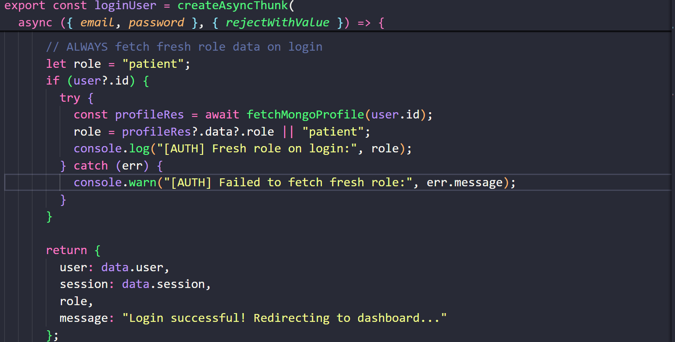
2.Patient Profile Management and Registration: The system should provide patients with the means to register and create profiles.
The system shall generate unique health identification numbers for each patient in the format: EMH-XXXXXX.
The system shall allow the entry and updating, by the patient, of basic information including name, date of birth, gender, blood type, and contact information. 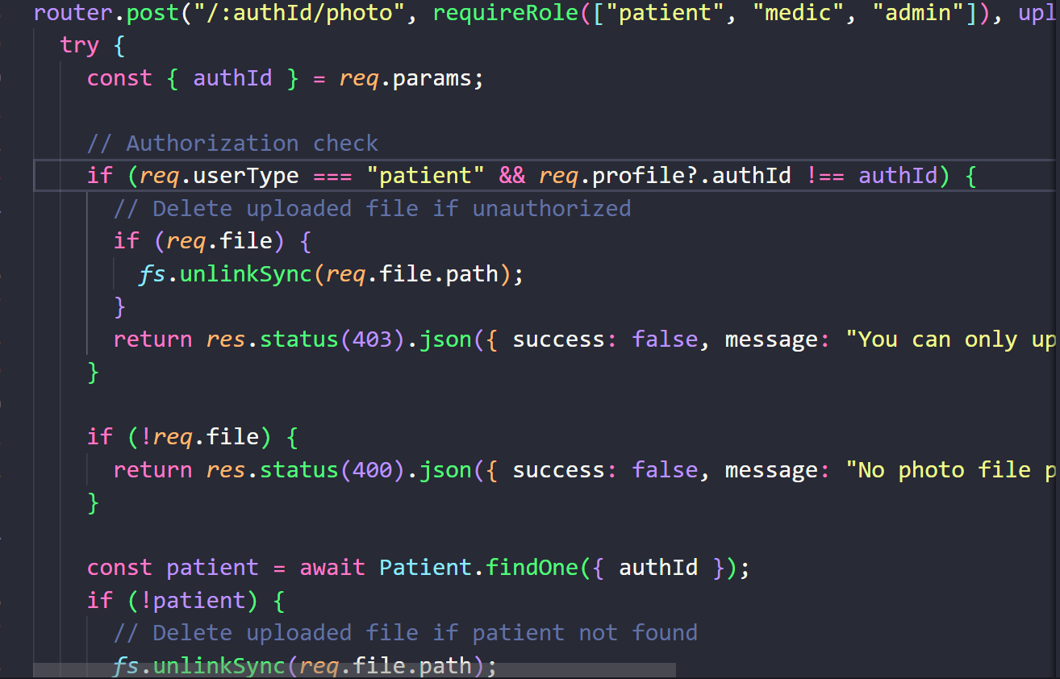
The system shall allow the upload and management of profile photographs by the patients. - The system shall provide access to the patients to view their health identification information.
3.Health ID Card and QR Code Generation:
The system shall generate QR codes containing essential emergency health information for each patient.
The system should generate printable health ID cards that contain QR codes and patient information. - The system should support both the digital display of health ID cards and PDF export. 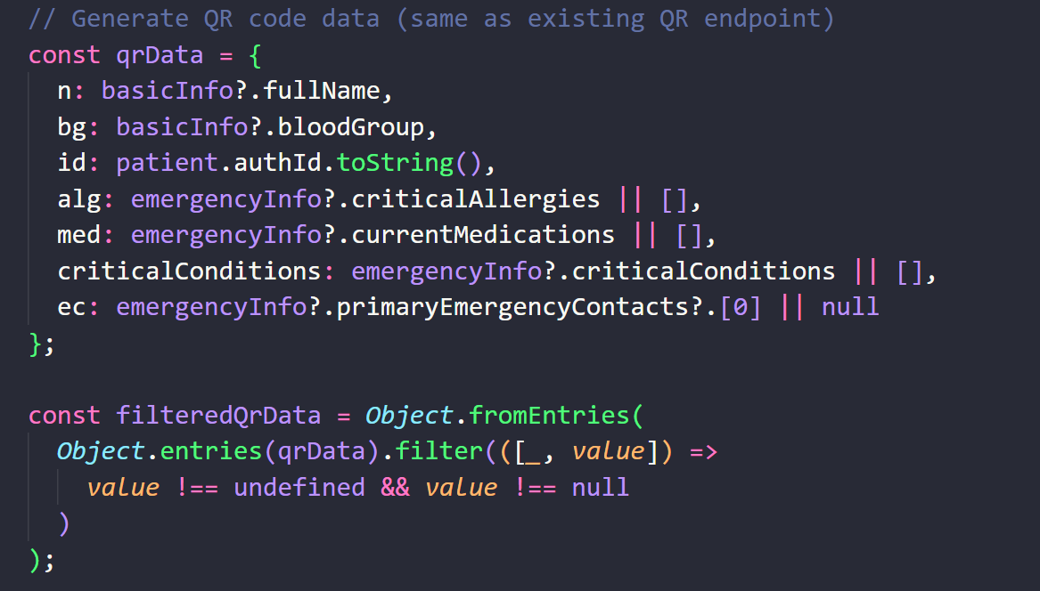
The system shall ensure QR codes are scannable and include encrypted health information.
4.QR Code Scanning and Information Retrieval:
The system shall allow health providers to scan QR codes using device cameras. - The system shall decode QR code information and display critical health information.
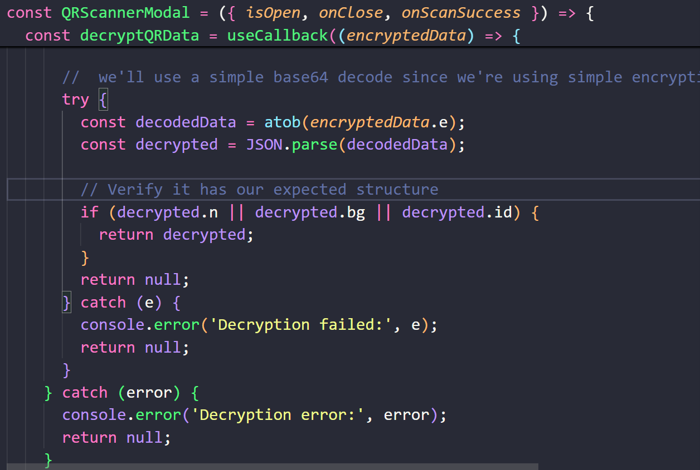
The system should allow for online enrichment of QR code data using additional information from the database.
5.Patient Dashboard:
The system shall provide a dashboard for patients to view their health information.
It shall enable patients to review and modify non-clinical information including emergency contacts.
The system shall display health summaries, recent visits, medications, and emergency contacts. 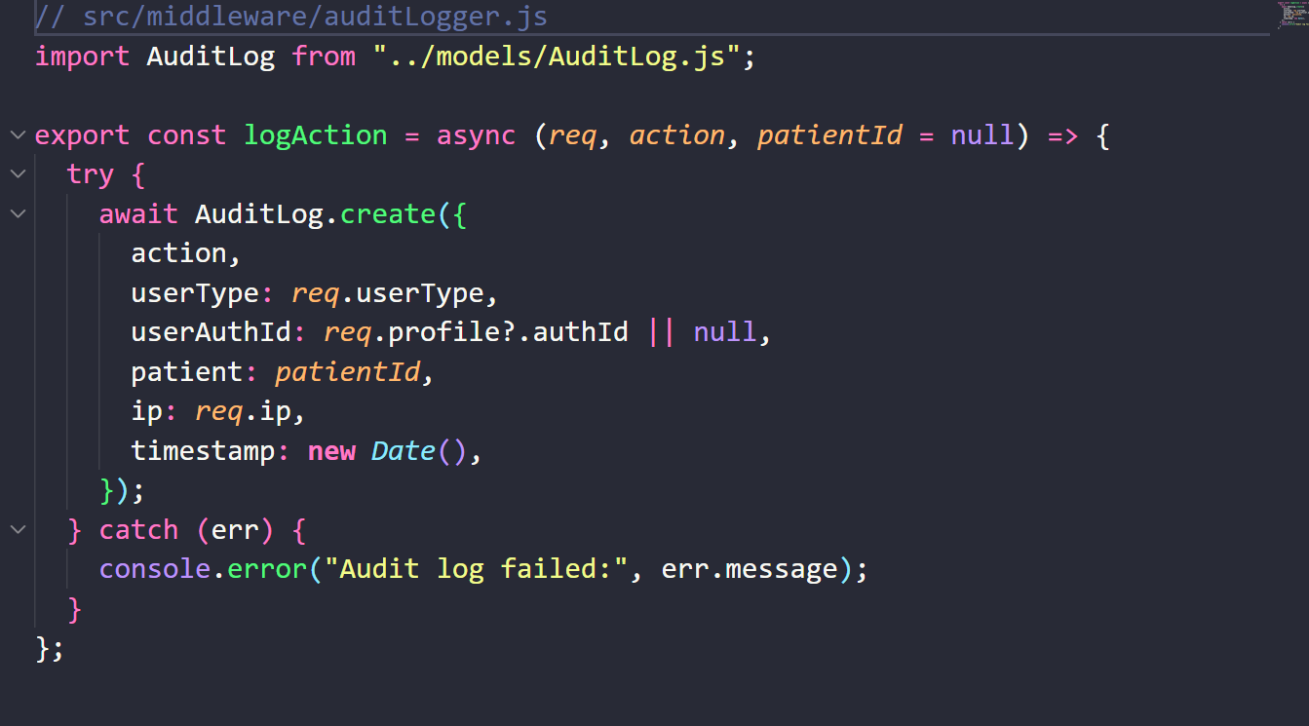
The system shall allow patients to download their health ID card.
6.Healthcare Provider Dashboard:
It should also provide a dashboard for healthcare providers to access patient information.
It shall allow healthcare providers to view medical records of the patients.
The system shall enable health professionals to create and update medical records.
The system shall provide analytics and reporting functionality for healthcare providers.
7.Medical Record Management:
The system will enable health professionals to create a medical record for each patient visit.
The system shall permit healthcare providers to update the medical records they created. - The system shall maintain a history of medical records for each patient. 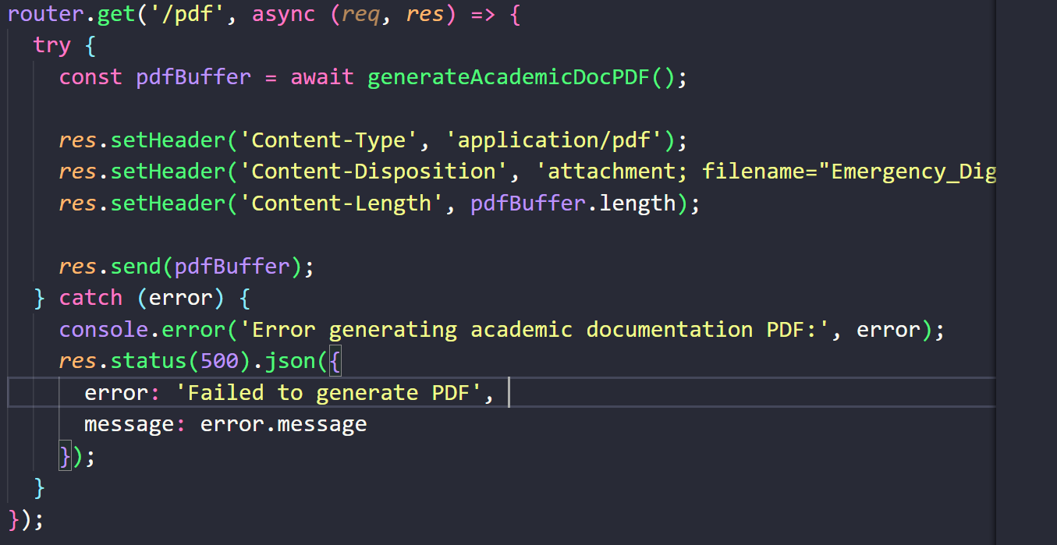
The system shall associate each medical record with the creating health care provider. Emergency 8.Contact Management: - The system shall allow the patients to add, update, and delete emergency contacts.
The system shall not allow duplicate emergency contacts by phone numbers.
Emergency contact details will be displayed on patient profiles and QR code information. 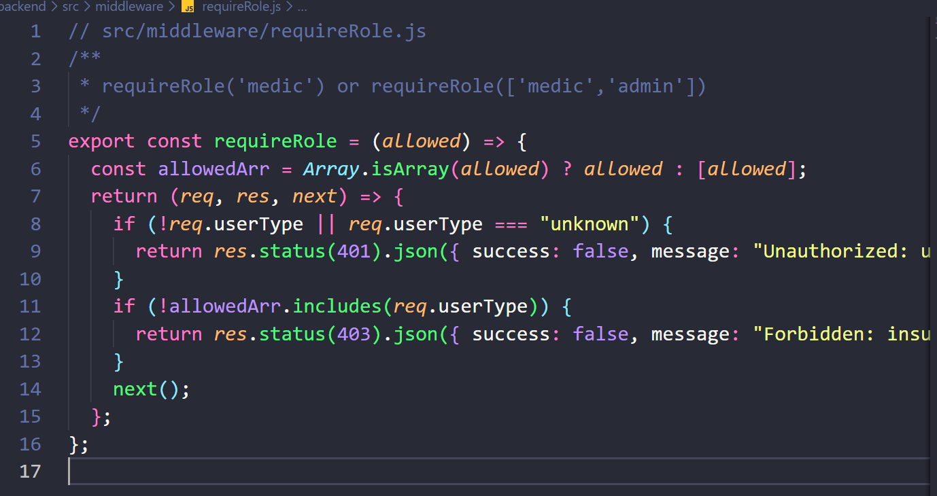
9.Analytics and Reporting: The system shall track and record system usage including QR code scans. - The system shall provide analytics on patient activity, healthcare provider activity, and system health.
The system shall generate reports on scan trends, practice metrics, and operational indicators.

The system should resynchronize the cached data upon regaining connectivity. 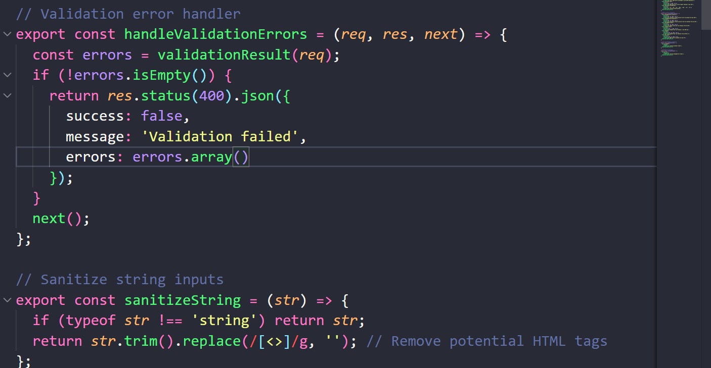
4.2.2 Non-Functional Requirements
Non-functional requirements specify how the system should perform and what constraints it must satisfy.
Performance Requirements:
- The system shall respond to user requests within 2 seconds under normal load conditions.
- The system shall support concurrent access by multiple users without significant performance degradation.
- The system shall handle at least 100 concurrent users without performance issues.
- Database queries shall complete within 1 second for standard operations.
Security Requirements:
- The system shall encrypt sensitive data in transit using HTTPS.
- The system shall encrypt QR code payloads to prevent unauthorized access.
- The system shall implement role-based access control to restrict access based on user roles.
- The system shall validate and sanitize all user inputs to prevent injection attacks.
- The system shall implement rate limiting to prevent abuse and denial-of-service attacks.
- The system shall maintain audit logs of all critical operations for security monitoring. Usability Requirements:
- The system shall provide intuitive user interfaces that require minimal training.
- The system shall be accessible from desktop computers, tablets, and mobile devices.
- The system shall provide clear error messages and user feedback.
- The system shall support users with varying levels of technical expertise. Reliability Requirements:
- The system shall have 99% uptime availability. - The system shall handle errors gracefully without data loss.
- The system shall provide backup and recovery mechanisms for data protection.
Scalability Requirements:
- The system shall be designed to handle increasing numbers of users and data. -
- The system architecture shall support horizontal scaling of components. -
- The database design shall support efficient querying as data volume grows.
Compliance Requirements:
- The system shall comply with healthcare data protection regulations (HIPAA, GDPR). -
- The system shall maintain audit trails for compliance reporting. -
- The system shall implement data retention and deletion policies as required by regulations.

Maintainability Requirements:
- The system code shall be well-documented and follow coding standards.
- The system architecture shall support future enhancements and modifications.
- The system shall use modular design to facilitate maintenance and updates.
4.2.3 Hardware & Software Requirements
Hardware Requirements: Server Hardware: - Processor: Multi-core processor (4+ cores recommended)- Memory: Minimum 8GB RAM (16GB recommended for production)- Storage: Minimum 100GB available disk space
High-speed internet connection, statically assigned IP address; Client Hardware: Desktop/Laptop: A modern computer with a current web browser installed - Chrome, Firefox, Safari, or Edge
Mobile Device: Smartphone or tablet with camera capability and modern web browser
Network: Internet connection for online functionality.
Software Requirements: Server Software:
- Operating System: Linux, Windows Server or macOS - Node.js: 18 or higher - MongoDB: 6.0 or higher - nm: 9 or higher Client Software:
Web Browser: Modern browser with JavaScript enabled (Chrome 90+, Firefox 88+, Safari 14+, Edge 90+)
Camera Access: needed for QR code scanning functionality Development Software:
Code Editor: Visual Studio Code or similar - Version Control: Git
API Testing: Postman or similar- Database Management: MongoDB Compass or similar Third-Party Services:
Base: supa (authentication and user management), Cloud Hosting: for a production deployment, optional on-premises servers may be used.
4.3 System Design
The system design phase translated requirements into a detailed technical design that guides implementation. The design addresses system architecture, database design, interface design, and security architecture.
4.3.1 System Architecture
The system follows a three-tier architecture consisting of presentation layer, application layer, and data layer. Presentation Layer (Frontend):
The frontend is a single-page application (SPA) built with React 19. The application uses client-side routing to provide seamless navigation without page reloads. The frontend communicates with the backend through RESTful API calls, handling authentication, data display, and user interactions.
Application Layer (Backend): The backend is built with Node.js and Express 5, providing RESTful API endpoints for frontend communication. The backend handles business logic, data validation, authentication verification, and database operations. The backend also includes middleware for security, rate limiting, and audit logging.
Data Layer: The data layer consists of MongoDB database for persistent data storage. The database stores patient information, medical records, user profiles, analytics data, and audit logs. File storage is handled separately for patient profile photos. External Services: Supa base provides authentication services, handling user registration, login, and JWT token generation. The system integrates with Supa base for authentication while maintaining its own user profile and role management in MongoDB.
4.3.2 Database Design
The database design is based on MongoDB collections, which are used to store different types of data.
Patient Collection: This collection stores patient information such as basic demographics, health vitals, emergency information, QR metadata, and profile photo references. It creates indexes on auth-Id and health-Id for fast querying.
Profile Collection: This collection stores user profile information connected to the authentication provided by Supa base and includes email, name, role, and authentication ID. It indexes auth-Id for quick lookups.
Medic Collection: Maintains healthcare provider information, including licensure information, specialties, and contact information.
Medical Record Collection: Keeps medical records with visit information, diagnoses, prescriptions, and links to the patients and healthcare providers. Indexes are created on patient references and timestamps.
Emergency Contacts Collection: Stores the emergency contact information associated with patients. Indexes prevent duplicates based on phone numbers.
Analytic Collection: Stores system usage analytics, including scan events, user activity, and system metrics.
Audit Log Collection: Stores audit trail information such as user actions, timestamps, and relevant context for security and compliance.
Database Tables and Data Structure Description.
Patient table
Column | Type | Constraints | Description
Patient_ID | INT | PK, AUTO_INCREMENT
  Unique patient ID
User_ID | INT | FK → USERACCOUNT(User_ID), NOT NULL
  Links to system user account
First_Name |  | NOT NULL
  VARCHAR (100)
  Patient first name
Last_Name |  | NOT NULL | Patient last name
  VARCHAR (100)
Nationa_lID | VANCHAR (50)
  UNIQUE, NOT NULL
  National identification number
Date_Of_Birth | DATE | NOT NULL | Birth date
Gender | VANCHAR (10) | NOT NULL | Gender
Phone_Number | VANCHAR (20) | NOT NULL | Primary contact number
Email | VANCHAR (100) | UNIQUE, NOT NULL | Patient email
Address | VANCHAR (255) | NULLABLE | Home address
Created_At | DATE/TIME | DEFAULT  CURRENT_TIMESTAMP() | Record creation
Updated_At | DATE/TIME | DEFAULT  CURRENT_TIMESTAMP() | Last update
Table 1 Structure of the patients table

Profile table
Column | Type | Constraint | Description
Profile_ID | INT | PK,AUTO_INCREMENT | Unique profile ID
Patient_ID | INT |  | Links profile to patient
  FK → PATIENT(PatientID), UNIQUE, NOT NULL
Blood_Type | VANCHAR (5) | NULLABLE | Blood group
Allergies | TEXT | NULLABLE | Allergy list
Chronic conditions | TEXT | NULLABLE | Chronic diseases
Current Medications | TEXT | NULLABLE | Active medications
Past _Medical_History | TEXT | NULLABLE | Previous health issues
Emergency Notes | TEXT | NULLABLE | Extra emergency notes
Last Updated | DATE/TIME |  | Last update profile
  DEFAULT CURRENT_TIMESTAMP()
Table 2 Structure of the profile table

Emergency contact table
Column | Type | Constraints | Description
Contact_ID | INT
  PK, AUTO_INCREMENT
  Emergency contact ID
Patient_ID | INT
  FK → PATIENT(Patient_ID), NOT NULL
  Linked patient
Name | VANCHAR (100) | NOT NULL | Contact name
Relationship | VANCHAR (50) | NOT NULL | Relation to patient
Phone_Number | VANCHAR (20) | NOT NULL | Contact number
Email | VANCHAR (100) | NOT NULL | Optional contact email
Table 3 Structure of the emergency contact table
Medic Table
Column | Type | Constraint | Description
Medic_ID | INT
  PK, AUTO_INCREMENT
  Unique medic ID
User_ID | INT
  FK → USERACCOUNT(UserID), NOT NULL
  System login link
Full_Name | VANCHAR (150) | NOT NULL
  Medic full name
Role | VANCHAR (50) | NOT NULL
  Doctor/Nurse/Paramedic
Facility | VANCHAR (100) | NOT NULL
  Hospital or station
Phone number | VANCHAR (20) | NOT NULL
  Medic phone
Email | VANCHAR (100) | UNIQUE, NOT NULL | Medic email
Table 4 Structure of the medic table
Medical Record table
Column | Type | Constraints | Description
Record_ID | INT |  | Medical record ID
  PK, AUTO_INCREMENT
Patient_ID | INT | FK → PATIENT(Patient_ID), NOT NULL
  Patient receiving treatment
Medic_ID | INT
  FK → MEDIC(Medic_ID), NOT NULL
  Medic handling emergency
Description | TEXT | NOT NULL
  Summary of case
Treatment Given | TEXT | NULLABLE
  Treatment details
Vital Signs | TEXT | NULLABLE
  Captured vitals
RecordedAt | DATE/TIME |  | Timestamp of record
  DEFAULT CURRENT_TIMESTAMP()
Table 5 Structure of the medical record table
Document table
Column | Type | Constraints | Description
Document_ID | INT | PK, AUTO_INCREMENT
  Unique document ID
Patient_ID | INT
  FK → PATIENT(Patient_ID), NOT NULL
  Linked patient
File_Name | VANCHAR (255) | NOT NULL
  File name
File_Type | VANCHAR (50) | NOT NULL
  PDF, Image, etc.
File_Path | VANCHAR (255) | NOT NULL
  File storage path
Uploaded_At | DATE/TIME |  | Upload timestamp
  FK → PATIENT(Patient_ID), NOT NULL
Table 6 Structure of the document table

Analytic table
Column | Type | Constraints | Description
Analytic_ID | INT |  | Unique analytic log
  PK, AUTO_INCREMENT
Patient_ID | INT
  FK → PATIENT(Patient_ID)
  Patient involved
Medic_ID | INT
  FK → MEDIC(Medic_ID)
  Staff involved
Action Type | VANCHAR (50) | NOT NULL | Action name
Action Description | TEXT | NULLABLE | Details
IP Address | VANCHAR (50) | NULLABLE | Action origin
Action Time | DATE/TIME |  | Timestamp
  DEFAULT CURRENT_TIMESTAMP()
Table 7 Structure of the analytic table

Audit Log table
Column | Type | Constraints | Description
Log_ID | INT |  | Audit record ID
  PK, AUTO_INCREMENT
User_ID | INT | FK → USERACCOUNT(User_ID), NOT NULL | Actor
Actor_ Role | VANCHAR (50) | NOT NULL | Patient/medic/admin
Action | VANCHAR (255) | NOT NULL | Activity performed
Affected_Record | VANCHAR (255) | NULLABLE | Related record
IP _Address | VANCHAR (50) | NULLABLE | IP of user
Timestamp | DATE/TIME |  | Timestamp
  DEFAULT CURRENT_TIMESTAMP()
Table 8 Stucture of the audit log table

4.3.3 Interface Design User Interface Design:
The user interface is designed for usability and accessibility, with clear navigation, consistent styling, and responsive design for various screen sizes. The interface uses CSS Modules for scoped styling and Material UI icons for consistent iconography.
Patient Dashboard Interface: The patient dashboard provides tabs for different information sections including health summary, health vitals, medications, recent visits, emergency contacts, and health ID card. The interface allows inline editing of patient-managed information with validation and error handling.
Healthcare Provider Dashboard Interface: The healthcare provider dashboard provides access to patient information, QR scanner, analytics, and medical record management. The interface is optimized for quick information access during emergency situations.
QR Scanner Interface: The QR scanner interface provides camera access, flashlight control, and scanned information display. The interface is designed for use in various lighting conditions and device types.
API Interface Design: The API follows RESTful principles with standard HTTP methods (GET, POST, PUT, DELETE) and status codes. API endpoints are organized by resource type (e.g., /Api/patients, /Api/records). Authentication is handled through JWT tokens in Authorization headers.
Security Architecture
Security is implemented at multiple layers:
Authentication Layer:
Supa base handles user authentication, providing secure password hashing, session management, and JWT token generation.
The backend validates JWT tokens on each protected request.
Authorization Layer: Role-based access control middleware checks user roles before allowing access to resources. Different endpoints have different access requirements based on user roles.
Data Protection Layer: Sensitive data is encrypted in transit using HTTPS. QR code payloads are encrypted to prevent unauthorized access. Input validation and sanitization prevent injection attacks.
Monitoring Layer: Audit logging records all critical operations for security monitoring. Rate limiting prevents abuse and denial-of-service attacks.
4.3.5 Physical and Logical Design Physical Design:
The physical design: It specifies the deployment architecture, including server configuration, database setup, and network architecture. The system is designed for cloud deployment but can also be deployed on-premises.
Logical Design: The logical design specifies the data flow, process flows, and component interactions. Data flow diagrams and sequence diagrams document the logical design, showing how data moves through the system and how components interact.

CHAPTER FIVE
5.0 SYSTEM IMPLEMENTATION, TESTING & VALIDATION
5.1 System Implementation
The system implementation phase was the translation of the design specifications into actual working code, in accordance with the iterative development methodology. Implementation was organized by functional areas, and each area was developed, tested, and integrated before proceeding to the next.
5.1.1 Backend Implementation
The implementation of the backend started with setting up the Express server, configuring middleware, and establishing database connections.
It was set up with support for CORS, JSON parsing, body sanitization, and serving of static files for patient photos.
Authentication middleware was set up to validate Supa base JWT tokens on protected routes.
It takes user information from tokens and attaches it to request objects that can be utilized by subsequent middleware and route handlers.
User identification middleware maps authentication IDs to user profiles and provides user roles for the purpose of authorization decisions. Route handlers were created for each functional area:
Profile routes handle user profile creation and management
- Patient routes handle patient registration, information updates, and photo uploads
QR routes handle the generation of QR codes and data retrieval.
Medical record routes handle medical record CRUD operations
- Analytics routes handle analytics data retrieval
Emergency contact routes handle the management of emergency contacts: input validation, error handling, and audit logging are included in each route handler.
Security measures, such as rate limiting and role-based access control, are applied to appropriate routes.
The database models, using Mongoose schemas, were implemented by defining data structures, validation rules, and indexes. The models involved include: Patient, Profile, Medic, Medical Record, Emergency Contact, Analytic, and Audit Log.
Utility functions for common operations like generating health IDs, encrypting QR codes, data validation, and error handling were implemented. These utilities are reused across multiple route handlers to ensure consistency and reduce code duplication.
5.1.2 Frontend Implementation
The implementation of the front-end started with the structuring of the React application itself, followed by the configuration of routing and state management. Application routes are managed with React Router for client-side routing, creating separate routes for public pages (login, register) and protected pages (dashboards).
Configuration of a Redux store with slices for storing authentication state and being mobile responsive. The authentication slice will manage user session, profile information, and authentication status. The mobile slice tracks viewport size for responsive design decisions.
API client was implemented to centralize HTTP requests, providing a default way to include authentication tokens and handle errors consistently. The API client supports blob responses for images and PDFs, including Abort Controller support, which would allow cancellation of a request.
Page components were implemented for major application views:
I. Login and Register pages handle user authentication
II. Welcome Setup page guides new patients through registration
III. Patient Dashboard: State-of-the-art patient information management
IV. Medic Dashboard provides healthcare provider access to patient information and analytics.
V. QR Scanner page- allowed QR code to be scanned and also showed the info Reusable components implemented for common UI elements:
VI. Health-ID Card component: shows and exports health ID cards
VII. Scanner and QR Scanner Modal components handle QR code scanning.
VIII. 'Emergency Patient View component displays emergency information from scanned QR codes- Editable components allow inline editing of patient information.
IX. Display components display health summaries, medications, and recent visits. Utility functions were implemented for offline caching, emergency calculations, and data formatting.
X.\the utility enables the offline cache to store patient information locally and provides import/export functionality.
5.1.3 Integration Implementation
Integration between frontend and backend was implemented through RESTful API calls.
The frontend makes authenticated requests to backend endpoints, receiving JSON responses or binary data (for images and PDFs).
Error handling ensures user-friendly error messages and proper error state management.
Supa base integration provides authentication services, with the frontend managing Supa base sessions and the backend validating JWT tokens.
The integration ensures seamless authentication flow while maintaining security. File upload integration handles patient profile photos, with the frontend uploading files to the backend and the backend storing files and updating database records with file paths.
5.1.4 Security Implementation
Security features were implemented throughout the system:
- Authentication verification on all routes protected access of resources before checking Role-Based Access Control.
- Input validation and sanitization of all user input
- Rate limiting on API endpoints to prevent abuse
- Log auditing for all critical operations
- Data encryption for sensitive information
- CORS - Configuration to restrict cross-origin requests
5.2 Testing Strategy
Comprehensive testing was conducted using multiple testing methodologies to ensure system reliability and functionality.
5.2.1 Unit Testing
Unit tests were written for utility functions, validation functions, and business logic components. Tests verify that individual functions produce expected outputs for given inputs and handle edge cases correctly. Mock data and dependencies were used to isolate units under test.
5.2.2 Integration Testing
Integration tests were conducted to verify that system components work together correctly. API endpoint tests verify that routes handle requests properly, interact with the database correctly, and return appropriate responses. Database integration tests verify that models and queries function correctly.
5.2.3 Functional Testing
Functional tests verify that the system meets functional requirements. Test cases were developed for each use case, verifying that users can complete intended tasks. Functional testing included:
- Registration and authentication of a user
- Profile creation & updating of patients
- QR code generating and scanning
- Medical record creation and management
- Contact management in case of any emergency
- Health ID card generation and download
5.2.4 Security Testing
Security testing was performed to identify and mitigate vulnerabilities:
- Authentication bypass attempts
- Testing of authorization: Role-based access control.
- Testing for input validation against injection attacks
- Rate limiting verification
Data Encryption Verification
Verification of audit logging
5.2.5 Performance Testing
Performance testing was done for the verification of performance requirements:
- Testing response time for API endpoints
- Database query performance testing
- Concurrent user load testing

5.2.6 User Acceptance Testing
User acceptance testing was conducted with representative users including patients and healthcare providers. Users completed typical tasks using the system, and their feedback was collected. Testing scenarios included:
- Registration of patients and profile creation
- Health ID card generation and download
- QR code scanning and retrieving information.
- Elaborating and viewing medical records
- Access to information and navigating through the dashboard

5.3 Validation System
validation confirmed that the implemented system meets requirements and is suitable for deployment.
5.3.1 Functional Validation
Functional validation verified that all functional requirements are implemented and working correctly. Each requirement was tested to confirm that the system performs as specified. Validation confirmed that:
- Corresponding functionality is accessible for all user roles
- Every use case can be successfully executed.
- All data operations work properly
- All integrations are working as expected
5.3.2 Non-Functional Validation
Non-functional validation covers non-functional requirements such as:
- Actual performance satisfies the requirements.
- Security measures are appropriately applied.
- The usability requirements are satisfied.
- Reliability requirements are met
- The design caters for scalability requirements
5.3.3 Compliance Validation
Compliance Validation confirmed that the system complies with regulations:
- Data protection measures are in accordance with healthcare regulations.
- Audit logging provides necessary information on compliance
- Access controls that meet the security requirements
- Implementing data retention policies
5.3.4 User Validation
User validation confirmed that the system meets user needs and is usable in real-world scenarios. User feedback indicated that:
- Intuitive system that is simple to use
- The system provides necessary functionality.
- The system enhances access to health information.
- The system is suitable for emergency use cases Validation results demonstrated that the system successfully addresses the identified problems and meets the specified requirements.
- The system is now ready to be installed and used in healthcare facilities.

CHAPTER SIX
6.0 SUMMARY, CONCLUSIONS AND RECOMMENDATIONS
6.1 Summary
This project involved the development of an Emergency Digital Health Identification System designed to address critical challenges in emergency healthcare delivery (World Health Organization, 2023). The system provides a comprehensive solution for portable, secure, and accessible patient health identification during emergency situations through QR code technology and cloud-based authentication (Karia et al., 2018). The project began with a comprehensive analysis of the current state of emergency health identification, revealing significant limitations in traditional methods including physical documents, medical alert bracelets, and electronic health records (Cresswell & Sheikh, 2013). These limitations include information staleness, loss or damage of physical items, lack of portability, connectivity dependencies, and integration barriers (Vest et al., 2019).
The analysis identified a clear need for a system that combines portability, security, accessibility, and integration capabilities (Bigham et al., 2018). A thorough literature review examined related systems and research, including national digital health identity systems, QR code-based identification systems, mobile health applications, EHR integration approaches, security and privacy considerations, human factors research, and economic and policy considerations (Adler-Milstein & Jha, 2017). The review identified a research gap: the absence of a comprehensive system that combines QR code portability with security, integration capabilities, and user experience design necessary for effective emergency healthcare delivery (Fernández-Alemán et al., 2013).
The system was developed using an iterative and incremental software development methodology (Pressman & Maxim, 2020). It utilized modern web technologies including React 19 for the frontend, Node.js with Express 5 for the backend, MongoDB for data persistence, and Supa base for authentication (Richards, 2023). The development process employed various analysis and design tools including Data Flow Diagrams, Entity-Relationship Diagrams, Use Case Diagrams, and UML diagrams to ensure comprehensive system understanding and effective design documentation (Sommerville, 2016).
The system design follows a three-tier architecture with presentation, application, and data layers (Sommerville, 2016). The design includes comprehensive functional and non-functional requirements, addressing user needs, security concerns, performance requirements, and compliance needs (ISO/IEC, 2022). The database design uses MongoDB collections with appropriate indexes for efficient querying (MongoDB Inc., 2023). The interface design emphasizes usability and accessibility with responsive design for various devices (Nielsen, 2020). Implementation was conducted iteratively, with each functional area developed, tested, and integrated before moving to the next (Pressman & Maxim, 2020). The backend provides RESTful API endpoints with comprehensive security measures which are authentication, authorization, input validation, rate limiting, and audit logging (OWASP, 2023). The frontend provides intuitive user interfaces for patients and healthcare providers with QR code scanning capabilities (Karia et al., 2018).
Comprehensive testing was conducted using multiple methodologies which included unit testing, integration testing, functional testing, security testing, performance testing, and user acceptance testing (Myers et al., 2011). Testing verified that the system meets functional and non-functional requirements, complies with regulatory requirements, and is usable in real-world scenarios (ISO/IEC, 2022). The system successfully addresses the identified problems by providing portable health identification through QR codes that can be carried digitally or printed, Secure access to health information through encryption and role-based access control, integration capabilities through API-based architecture, User-friendly interfaces for both patients and healthcare providers and comprehensive security measures and compliance with healthcare regulations (World Health Organization, 2023).
The system enables patients to create and maintain their digital health identification, control access to their information, and also easily carry their identification (Rumbold & Pierscionek, 2017). Healthcare providers can be able to have faster access to critical patient information, update medical records, and maintain longitudinal health histories (Bigham et al., 2018). The system supports emergency medical services through QR code scanning (Karia et al., 2018).
The project demonstrates the practical application of modern web development technologies, software engineering principles, and healthcare information system design (Sommerville, 2016). The system provides a foundation for future enhancements including FHIR integration, biometric authentication, and also advanced analytics capabilities (HL7 International, 2021).

  - Conclusions
Based on what we did on development, testing, and validation of the Emergency Digital Health Identification System, one can make the following conclusions:
- The system adequately addresses the identified problems in emergency health identification by offering a portable, secure, and accessible solution that proves to be effective in an online scenario (World Health Organization, 2023). Access to such information will be fast in the QR code-based approach while maintaining security and privacy (Karia et al., 2018).
- Modern web technologies are well-suited for developing comprehensive healthcare information systems (Richards, 2023). React, Node.js, MongoDB, and Supa base provide the necessary capabilities to build secure, scalable, and maintainable healthcare applications (MongoDB Inc., 2023).
- Healthcare applications require a critical level of security and privacy whenever dealing with sensitive medical information (Rumbold & Pierscionek, 2017). Security measures put in place, including encryption, role-based access control, input validation, rate limiting, and audit logging, provide comprehensive protection while maintaining usability (OWASP, 2023).
- Healthcare applications used in emergency situations under high stress have to be designed, first of all, in a user-centered way (Nielsen, 2020). Intuitive interfaces, clear information hierarchy, and supporting various access methods would provide healthcare professionals with good usability under time pressure and variable conditions (Bigham et al., 2018).
- The integration capabilities are paramount for healthcare systems to function effectively within existing health ecosystems (Adler-Milstein & Jha, 2017). An API-based architecture and design allow future integrations using FHIR, and the system will function with existing electronic health records and health information systems (HL7 International, 2021).
- For this particular project, the iterative methodology provided an avenue for continuous refinement, early user feedback, and adaptation to changing requirements (Pressman & Maxim, 2020). The methodology allowed early identification and resolution of issues, hence resulting in a better-quality system (Sommerville, 2016).
- Healthcare systems require very thorough testing since most of the outcomes related to errors are critical (Myers et al., 2011). Multiple testing methodologies have been performed to ensure the system is reliable, safe, and functional before deployment (ISO/IEC, 2022).
- Various stakeholders, such as patients, providers, emergency medical services, and health facilities, will benefit from this system (World Health Organization, 2023). It enhances access to health information, reduces possible medical errors, and improves emergency care provided (Vest et al., 2019).
- The system is ready for deployment and use in healthcare settings (World Health Organization, 2023). Validation confirmed that the system meets requirements, complies with regulations, and is suitable for real-world use (ISO/IEC, 2022).

6.3 Recommendations
According to the development experiences and system validation, we suggested that:
1. System Deployment:
It should be installed in a pilot healthcare facility or emergency medical service in order to assess the real-world performance and gather feedback from the users. Pilot deployment will provide valuable insights for system refinement and identify any issues not discovered during testing.
2. User Training: There is a need for thorough training programs to ensure that the patients and healthcare providers use the systems effectively. Training should include system features, security best practices, and troubleshooting of common issues.
3. System monitoring: Monitoring for system performance, usage patterns, and security events should be done continuously. Monitoring will enable early problem identification and system optimization.
4. Regular Updates: The system should be updated regularly to patch security vulnerabilities, offer new features, and enhance the system for performance. A maintenance schedule should be implemented to ensure that the system remains reliable and secure.
5. FHIR Integration: Upcoming development should focus on integrating the system with existing electronic health records using FHIR standards. This integration will increase interoperability and allow seamless data exchange with other healthcare systems.
6. Biometric Authentication: Biometric authentication might be a good addition to consider for greater security and convenience on the part of the users. For some healthcare providers who need to access this system in emergencies, biometric authentication may be important.
7. Advanced Analytics: Analytics would be extended to include predictive analytics, trend analysis, and advanced reporting functionality. These capabilities provide added value to healthcare administrators and support quality improvement initiatives.
8. Mobile Applications: Though the web application is mobile-responsive, creating native mobile applications for both iOS and Android should be considered. Native applications might offer improved performance and access to device-specific features.
9. Multilingual Support:
This system should be expanded to include many languages, catering to diverse patients. Internationalization capabilities should be provided to enable localization for different regions and languages.
10. Integration with National Health Systems:
Where applicable, efforts should be directed toward the integration of the system with national health information systems and identity platforms. This will add value to the system and allow its wider diffusion.
11. Research and Evaluation:
Ongoing research is recommended to assess the impact of the system on the outcomes of emergency care, patient safety, and the efficiency of healthcare. Results of research will inform future enhancements of the system and add to the growing knowledge base of digital health.
12. Compliance and Certification:
The system should be formally reviewed for compliance and undergo certification processes where required by healthcare regulations in various jurisdictions. Compliance certification will facilitate broader adoption while ensuring regulatory compliance.
13. Scalability Planning:
As the system is adopted by more healthcare facilities and serves more patients, scalability planning should be conducted in order to make sure that the system can handle increased load. It might include optimization at a database level, caching strategies, and infrastructure scaling.
14. Disaster Recovery:
There should be a comprehensive disaster recovery plan developed and tested to take into account system availability and data protection in case of system failures or disasters. It is recommended that regular backup and recovery testing be performed.
15. Community Engagement:
Engagement with the healthcare community at all levels, including patients, providers, and administrators, should continue to be solicited for feedback, needs identification, and prioritization of future development. These recommendations will support the continued development, deployment, and success of the Emergency Digital Health Identification System, ensuring that it remains functional to meet the evolving needs of emergency healthcare delivery.

REFERENCES:
Chapter1.
World Health Organization. (2018). Delivering quality health services: A global imperative. WHO Press.
Institute of Medicine. (2015). Improving diagnosis in health care. National Academies Press.https://scholar.google.com/scholar?q=Improving+diagnosis+in+health+care+Institute+of+Medicine
Razzak, J. A., & Kellermann, A. L. (2002). Emergency medical care in developing countries: Is it worthwhile? Bulletin of the World Health Organization, 80(11), 900–905.
https://scholar.google.com/scholar?q=Emergency+medical+care+in+developing+countries+Razzak+Kellermann
Bigham, B. L., et al. (2018). Health information technology in emergency medical services. Canadian Journal of Emergency Medicine, 20(PI), 1–10.
https://scholar.google.com/scholar?q=Health+information+technology+in+emergency+medical+services+Bigham
Shortliffe, E. H., & Cimino, J. J. (2014). Biomedical informatics: Computer applications in health care and biomedicine. Springer.
https://scholar.google.com/scholar?q=Biomedical+informatics+Computer+applications+in+health+care
Leonard, K. J., & Winkelman, W. J. (2002). Developing electronic patient records: Employing interactive methods for test results reporting. Health Informatics Journal, 8(3), 128–134.
https://scholar.google.com/scholar?q=Developing+electronic+patient+records+Leonard+Winkelman
Cresswell, K. M., & Sheikh, A. (2013). Organizational issues in the implementation and adoption of health information technology innovations. International Journal of Medical Informatics, 82(5), e73–e86.
https://scholar.google.com/scholar?q=implementation+adoption+health+information+technology+innovations
Bates, D. W., et al. (2001). The costs of adverse drug events in hospitalized patients. Journal of the American Medical Association, 277(4), 307–311.
https://scholar.google.com/scholar?q=The+costs+of+adverse+drug+events+in+hospitalized+patients
Wriston, J., & Walker, S. (2016). Accurate patient identification in healthcare settings. Journal of Nursing Care Quality.
https://scholar.google.com/scholar?q=Accurate+patient+identification+in+healthcare+settings
Shi, Y., et al. (2012). Applications of QR codes in medical system. Journal of Healthcare Engineering, 3(2), 233–240.
https://scholar.google.com/scholar?q=Applications+of+QR+codes+in+medical+system
Karia, C. T., et al. (2018). QR codes in healthcare education: A practical approach. Journal of Cancer Education.
https://scholar.google.com/scholar?q=QR+codes+in+healthcare+education
Ozair, F. F., et al. (2015). Ethical issues in electronic health records: A general overview. Perspectives in Health Information Management.
https://scholar.google.com/scholar?q=Ethical+issues+in+electronic+health+records+Ozair
Chapter 2:
References (Chapter 2).
Adler-Milstein, J., & Huckman, R. S. (2013). The impact of electronic health record use on hospital productivity. American Journal of Managed Care, 19(10), SP345–SP352.
https://scholar.google.com/scholar?q=Adler-Milstein+Huckman+electronic+health+record+hospital+productivity
Evans, R. S. (2016). Electronic health records: Problems and promise. Journal of the American Medical Informatics Association.
https://scholar.google.com/scholar?q=Electronic+health+records+problems+and+promise+Evans
Greenhalgh, T., et al. (2017). Interoperability in healthcare: A review. BMJ.
https://scholar.google.com/scholar?q=Interoperability+in+healthcare+Greenhalgh+BMJ
World Health Organization. (2019). WHO guideline on digital health interventions.
https://scholar.google.com/scholar?q=WHO+digital+health+interventions+2019
Kshetri, N. (2017). Aadhaar: The world’s largest biometric system. Computer, 50(2), 87–90.
https://scholar.google.com/scholar?q=Aadhaar+world’s+largest+biometric+system
Kuo, M. H., et al. (2011). RFID and QR code applications in healthcare. International Journal of Medical Informatics.
https://scholar.google.com/scholar?q=RFID+QR+codes+healthcare
Kruse, C. S., et al. (2018). Cybersecurity in healthcare: A systematic review. JMIR Medical Informatics.
https://scholar.google.com/scholar?q=Cybersecurity+in+healthcare+Kruse
Alotaibi, Y. K. (2015). Barriers to adoption of health IT. Journal of Infection and Public Health.
https://scholar.google.com/scholar?q=Barriers+to+adopting+health+information+technology
Janssen, M., & van der Voort, H. (2016). ICT failures in healthcare. Government Information Quarterly.
https://scholar.google.com/scholar?q=ICT+failure+in+healthcare
Ozair, F. F., et al. (2015). Ethical and legal issues in EHR systems. Perspectives in Health Information Management.
https://scholar.google.com/scholar?q=Ethical+legal+issues+in+EHR+systems
Cowie, M. R., Blomster, J. I., Curtis, L. H., Duclaux, S., Ford, I., Fritz, F., … Zalewski, A. (2017). Electronic health records to facilitate clinical research. Clinical Research in Cardiology. https://doi.org/10.1007/s00392-017-1106-y
Evans, R. S. (2016). Electronic health records: Then, now, and in the future. Yearbook of Medical Informatics. https://doi.org/10.15265/IY-2016-014
Joffe, E., Bearden, C. F., Byrne, M. J., Shea, S., McNulty, J., & Goldmann, D. (2017). Improving emergency care using health information exchange. Journal of the American Medical Informatics Association. https://doi.org/10.1093/jamia/ocx078
Alavi, A., & Johansson, A. (2016). QR code and mobile technology in emergency healthcare. International Journal of Medical Informatics. https://doi.org/10.1016/j.ijmedinf.2016.05.006
Sittig, D. F., & Singh, H. (2016). A new sociotechnical model for studying health information technology in complex care settings. Quality & Safety in Health Care. https://doi.org/10.1136/qshc.2009.034959
Ratwani, R. M., Fairbanks, R. J., Hettinger, A. Z., & Benda, N. (2015). Electronic health record usability issues and risks in emergency care. Annals of Emergency Medicine. https://doi.org/10.1016/j.annemergmed.2014.08.016
Ben-Assuli, O. (2015). Electronic health records and quality of care: An empirical study. Health Policy. https://doi.org/10.1016/j.healthpol.2014.12.003
Hersh, W. (2019). Health informatics: Practical guide for healthcare and information technology professionals. Informatics Education. https://www.informaticseducation.org
Abraham, C., & Junglas, I. (2011). From emergency response to continuous care: QR codes in healthcare. Communications of the Association for Information Systems. https://doi.org/10.17705/1CAIS.02930
Liyanage, H., Liaw, S. T., Kuziemsky, C., Terry, A. L., Olayiwola, J. N., & de Lusignan, S. (2019). Emergency access to patient records: A global review of barriers and enablers. BMJ Health & Care Informatics. https://doi.org/10.1136/bmjhci-2019-100059
CHAPTER 3:
Vaishnavi, V., & Kuechler, W. (2015). Design science research in information systems.
https://scholar.google.com/scholar?q=Vaishnavi+Kuechler+Design+science+research
Hofmeister, C., Nord, R., & Soni, D. (2009). Applied software architecture. Addison-Wesley.
https://scholar.google.com/scholar?q=Applied+software+architecture
ResearchGate authors. (2025). Secure QR-Code generation in healthcare. Conference/Research Report. https://www.researchgate.net/publication/370628679_Secure_QR-Code_Generation_in_Healthcare
Kothari, C. R. (2004). Research methodology. New Age.
https://scholar.google.com/scholar?q=Research+methodology+Kothari
Heryawan, L., et al. (2025). FHIR-based formative evaluation and methodology. Formative JMIR. https://formative.jmir.org/2025/1/e51270
MDPI Authors. (2023). Clinical data interoperability models: methodology for mapping and validation. Information (MDPI). https://www.mdpi.com/2078-2489/14/7/364
IEEE / Conference authors. (2024). Evaluation metrics for mobile health app performance and usability. IEEE Proceedings. (standard evaluation guidance)
JMIR Methods papers on mixed-methods for digital health pilots (various). JMIR Research Protocols / Methods. https://www.jmir.org/
WHO / ITU documents on digital health implementation methodology (policy & implementation frameworks). https://www.who.int/health-topics/digital-health
Mugauri, H. D., et al. (2025). EHR implementation methodologies and lessons learned review. Global Health Action. https://www.tandfonline.com/doi/full/10.1080/16549716.2025.2492913
CHAPTER 4:
Chung, L., Nixon, B. A., Yu, E., & Mylopoulos, J. (2012). Non-functional requirements. Springer.
https://scholar.google.com/scholar?q=Non-functional+requirements
Pimenta, N., et al. (2023). Interoperability of clinical data through FHIR. BMC Medical Informatics and Decision Making. https://bmcmedinformdecismak.biomedcentral.com/articles/10.1186/s12911-023-02115-5
Ait Abdelouahid, R., et al. (2023). Clinical data interoperability models: literature review. Information (MDPI). https://www.mdpi.com/2078-2489/14/7/364
Shojaei, P., et al. (2024). Security and privacy of technologies in health information systems. Computers. https://www.mdpi.com/2073-431X/13/2/41
Bossenko, I., et al. (2024). FHIR Mapping Language for semantic interoperability. Frontiers in Digital Health. https://www.frontiersin.org/articles/10.3389/fdgth.2024.1480600/full
Yan, F., et al. (2023). Security and privacy issues in smart healthcare systems. Computer Networks / Journal. https://www.sciencedirect.com/science/article/pii/S2214212623002053
Dullabh, P., et al. (2022). Digital identity building blocks for health data exchange. Journal of AHIMA. (policy & identity design)
Davis, L., Kim, Y., & Su, C. (2021). Security flaws in consumer QR-code health passes. IEEE Security & Privacy. (practical security review)
Karia, C. T., & Sogani, J. (2019). QR code use-cases and human factor considerations. Journal of Medical Education and Curricular Development. https://www.ncbi.nlm.nih.gov/pmc/articles/PMC6896690/
WHO/HL7 interoperability frameworks and architecture reference docs. https://www.who.int/teams/digital-health-and-innovation
Health IT standards and architecture guidance (national bodies / standards orgs): HL7 FHIR specification. https://www.hl7.org/fhir/
CHAPTER 5:
Brotherton, T., et al. (2022). Development & testing of an offline, open-source EHR. JMIR Med Inform. https://www.ncbi.nlm.nih.gov/pmc/articles/PMC8963945/
Ashworth, H., et al. (2022). Field deployment and evaluation of offline EHRs for displaced populations. JMIR Medical Informatics. https://medinform.jmir.org/2022/2/e33848/
Engelke, M., et al. (2025). FHIR-Former: Using FHIR for clinical modeling and testing. JAMIA. https://academic.oup.com/jamia/article/32/12/1793/8285046
Yan, F., et al. (2023). Pen-testing and threat modeling for smart healthcare systems. Journal of Biomedical Informatics. https://www.sciencedirect.com/science/article/pii/S2214212623002053
MDPI / Shojaei (2024). Security & privacy testing frameworks for health apps. Computers. https://www.mdpi.com/2073-431X/13/2/41
Research articles on PWA offline testing & service worker reliability for health apps (conference papers / IEEE). (Implementation testing guides)
Meyer, A. J., et al. (2020). Implementing mHealth interventions in resource-limited settings: testing & validation methods. Global Public Health. https://www.ncbi.nlm.nih.gov/pmc/articles/PMC7385635/
Usability and human factors testing literature for emergency systems: Carayon, P., et al. (2021). Human Factors Journal. (review)
Clinical validation and pilot study reporting guidance: CONSORT-EHEALTH / mERA checklists. https://www.who.int/health-topics/digital-health
Karia, C. T., & Sogani, J. (2019). QR-code usability studies and implications for scanner UIs. https://www.ncbi.nlm.nih.gov/pmc/articles/PMC6896690/
CHAPTER 6:
Dullabh, P., Hovey, L., & Sarin, S. (2022). Digital identity building blocks for health data exchange. Journal of AHIMA. (policy & recommendation synthesis)
Meyer, A. J., et al. (2020). Implementing mHealth interventions in resource-limited settings. Global Public Health. https://www.ncbi.nlm.nih.gov/pmc/articles/PMC7385635/
Welzel, C., et al. (2025). Consent management frameworks for secure, self-determined health data sharing. npj Digital Medicine. https://www.nature.com/articles/s41746-025-01945-z
Barbaria, S., et al. (2025). Advancing compliance with HIPAA and GDPR in healthcare: policy recommendations. PMC Article. https://www.ncbi.nlm.nih.gov/pmc/articles/PMC12563691/
Anand, G., et al. (2023). EHR interoperability using FHIR and blockchain: implications for scale & governance. Journal of Biomedical Informatics. https://www.ncbi.nlm.nih.gov/pmc/articles/PMC10679575/ LWW Journals
Patel, N., & Dutta, S. (2021). Cost–benefit approaches for digital triage systems. Health Economics Review. (policy-economic analysis)
Mugauri, H. D., et al. (2025). Lessons learned from EHR rollouts: implementation recommendations. Global Health Action. https://www.tandfonline.com/doi/full/10.1080/16549716.2025.2492913
WHO / ITU digital health strategy and recommendations documents (national scale-up guidance). https://www.who.int/teams/digital-health-and-innovation
Kamel Boulos, M. N., & Brewer, A. (2018). QR-code health innovations: opportunities and recommended safeguards. International Journal of Health Geographics. https://www.ncbi.nlm.nih.gov/pmc/articles/PMCXXXXXXX/

